Thursday, October 6, 2016

Wednesday, October 19, 2016

9:05 AM

**Objective**

* To prepare liquid phage samples of decreasing concentrations
* Determine the concentration of phage particles in a lysate using a spot test and plaque assay
* Prepare sample for plating and incubation

**Procedure**

* I followed the Serial Dilution, Spot and Full Plate Titer, and Plating a Sample Procedures today
  + I entered the lab, washed my hands, and cleaned off my work area with the brown detergent and ethanol.
  + My partner retrieved the lysate she had collected yesterday with Stephen. She had collected about 20 ml of lysate from the two plates.
  + We got all the supplies we needed for the day.
  + We labeled all of the plates we would be using today and my partner set up the bacterial lawn we would use for the spot titer.
  + We mixed 3ml of agar with a bacteria sample, vortexed it, and poured it onto the spot titer plate. We swirled it to coat the plate evenly with agar and bacteria, and let it harden.
  + During this time, we performed the serial dilution from 10^-1 to 10^-8.
  + We then infected 8 bacterial samples with 10 microL of each of the serial dilutions.
  + Then, we spotted 3ml of each of the serial dilutions, and on the negative control 3 microL of phage buffer, onto the bacterial lawn in their correct spots that we had marked. The agar was even, so there was no reason to believe that the phage will spread to another area in the bacterial lawn.
  + We added agar to the infected bacterial samples and plated each of the serial dilutions, including a negative control, which had been "infected" with phage buffer.
  + We cleaned up our work area and washed our hands.

**Future Actions**

* On Thursday, October 13, we will inspect the plates made today and determine the titer of the lysate.

Thursday, October 13, 2016

Thursday, October 13, 2016

11:30 AM

**Objective**

* To prepare liquid phage samples of decreasing concentrations
* Determine the concentration of phage particles in a lysate using a spot test and plaque assay
* Prepare sample for plating and incubation

**Procedure**

* I followed the Serial Dilution, Full Plate Titer, and Plating a Sample Procedures today
  + I entered the lab, washed my hands, and cleaned off my work area with the brown detergent and ethanol.
  + I retrieved the titer plates we had created last week.
  + My partner and I inspected them, recorded our observations, and took pictures of the plates. (See Tables 10 & 11 and Figures 46-55)
    - The titer of the lysate is so high that all of the plates were too clear to determine the titer.
    - After consulting with Soo, we determined that we needed to create even more diluted serial dilutions to determine the titer.
  + We got all the supplies we needed for the day.
  + We labeled all of the plates we would be using today.
  + During this time, we created a 1% dilution of the lysate by pipetting 198 microL of phage buffer and 2 microL of lysate into a microcentrifuge tube.
  + We pipetted 198 microL of phage buffer into 5 more microcentrifuge tubes, and then created serial dilutions from 10^-2 down to 10^-12.
  + We then infected 6 bacterial samples with 10 microL of each of the serial dilutions.
  + After 10 minutes, we added agar to the infected bacterial samples and plated each of the serial dilutions, including a negative control, which had been "infected" with phage buffer.
  + We cleaned up our work area and washed our hands.

**Data**

*Table 10: Spot Plate Titer Observations #2*

|  |  |  |
| --- | --- | --- |
| Spot | Observations | Titer Calculated |
| Negative Control | Two possible plaques, probably spread from 10^-1 | N/A |
| 10^-1 | 5 medium-large plaques, the largest plaque is about 1 inch across and the smaller are about 1/4 inch across | Unable to count |
| 10^-2 | One large plaque, about 1/2 inch across, but running into the edge of the plate | Unable to count |
| 10^-3 | One large plaque, about 3/4 inch across | Unable to count |
| 10^-4 | One large plaque, about 1/2 inch across | Unable to count |
| 10^-5 | One large plaque, about 1/2 inch across | Unable to count |
| 10^-6 | One large plaque, about 1/2 inch across | Unable to count |
| 10^-7 | One large plaque, about 1/2 inch across | Unable to count |
| 10^-8 | One large plaque, about 1/2 inch across | Unable to count |

*Table 11: Full Plate Titer Observations #2*

|  |  |  |
| --- | --- | --- |
| Plate | Observations | Titer Calculated |
| Negative Control | No plaques; some air bubbles | N/A |
| 10^-1 | Completely clear | Unable to count |
| 10^-2 | Completely clear | Unable to count |
| 10^-3 | Completely clear | Unable to count |
| 10^-4 | Completely clear | Unable to count |
| 10^-5 | Almost completely clear; some small webbing on one side of the plate | Unable to count |
| 10^-6 | Completely clear | Unable to count |
| 10^-7 | Completely clear | Unable to count |
| 10^-8 | Almost completely clear; some webbing in areas of the plate | Unable to count |

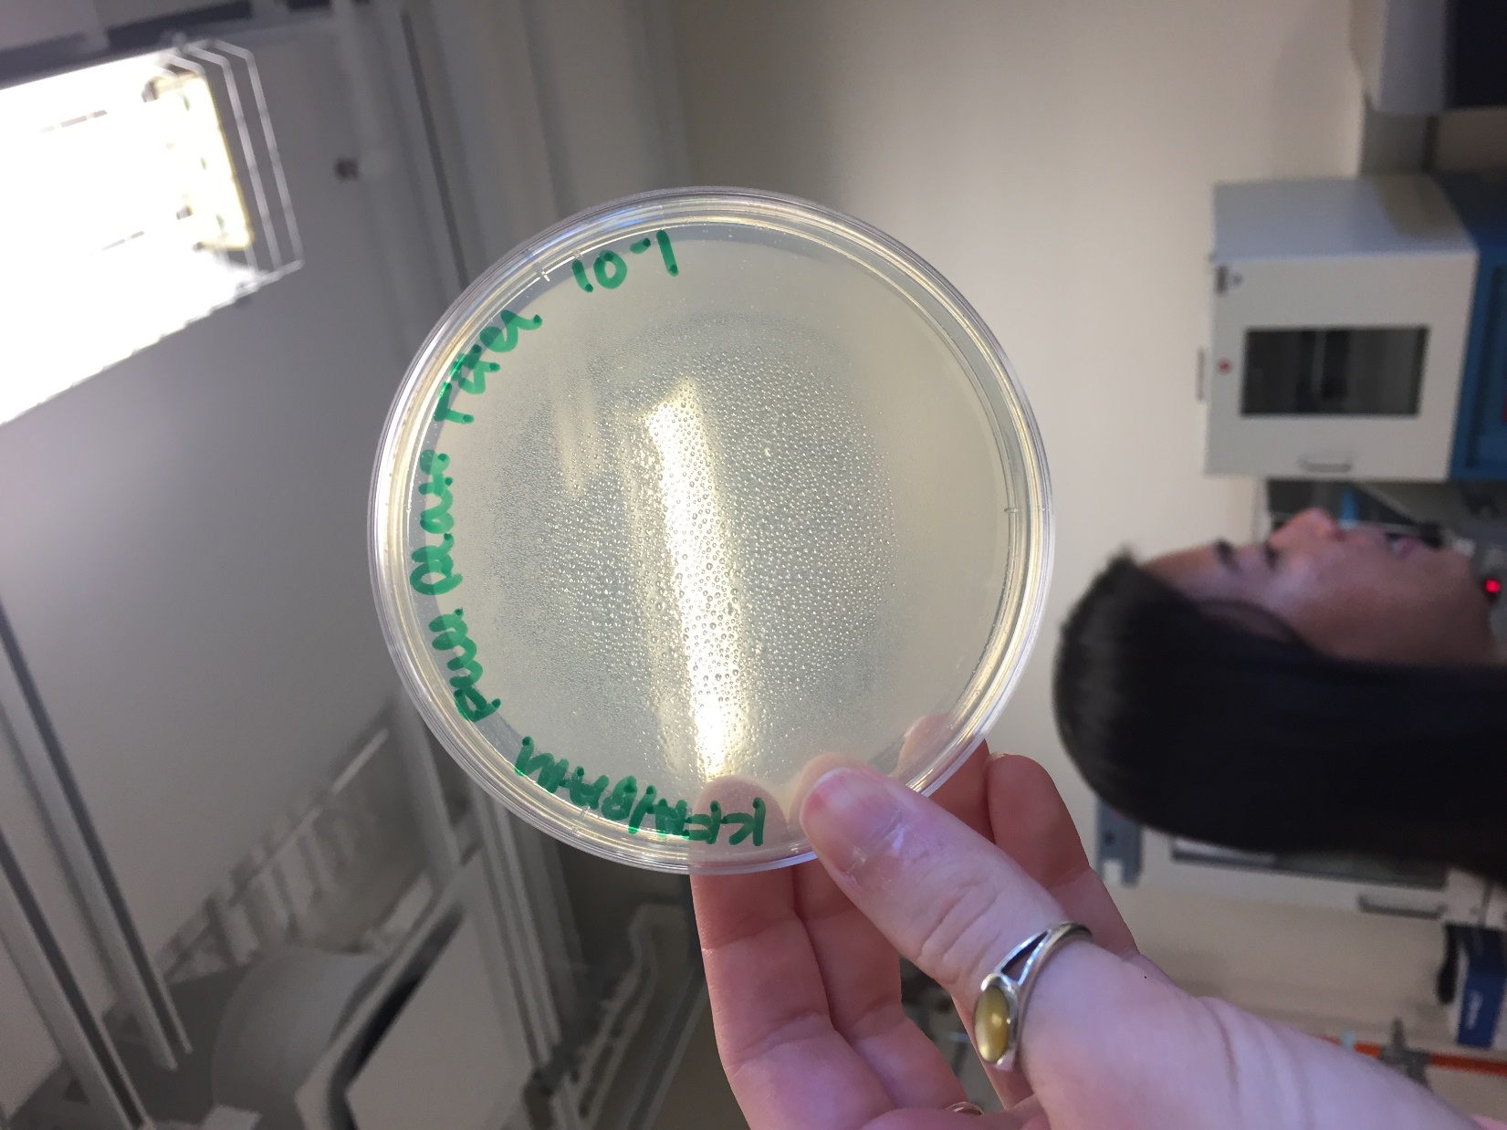

*Figure 46: Full Plate Titer 10^-1*

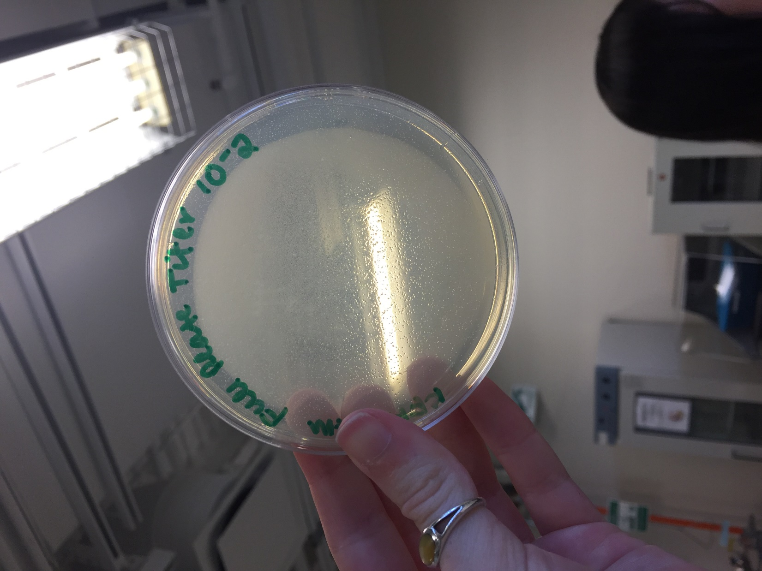

*Figure 47: Full Plate Titer 10^-2*

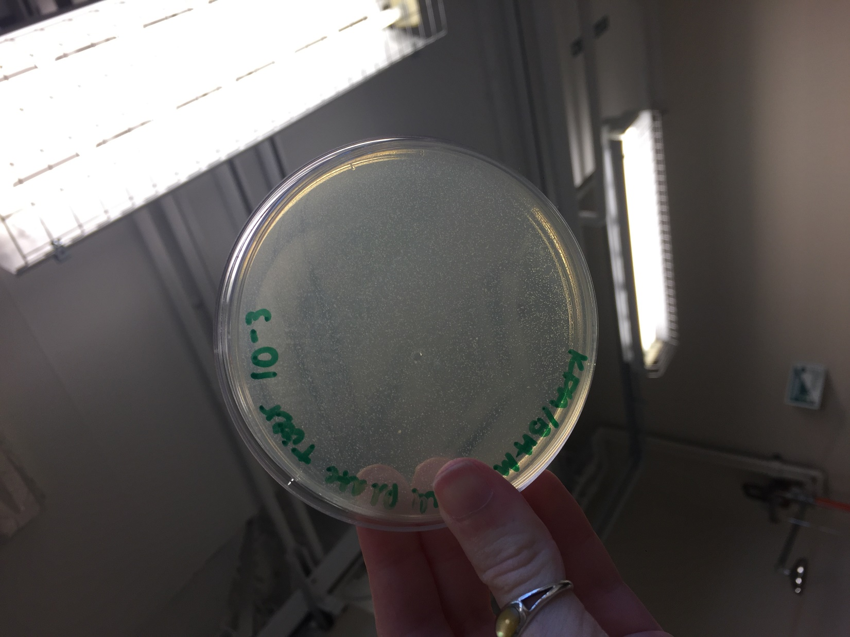

*Figure 48: Full Plate Titer 10^-3*

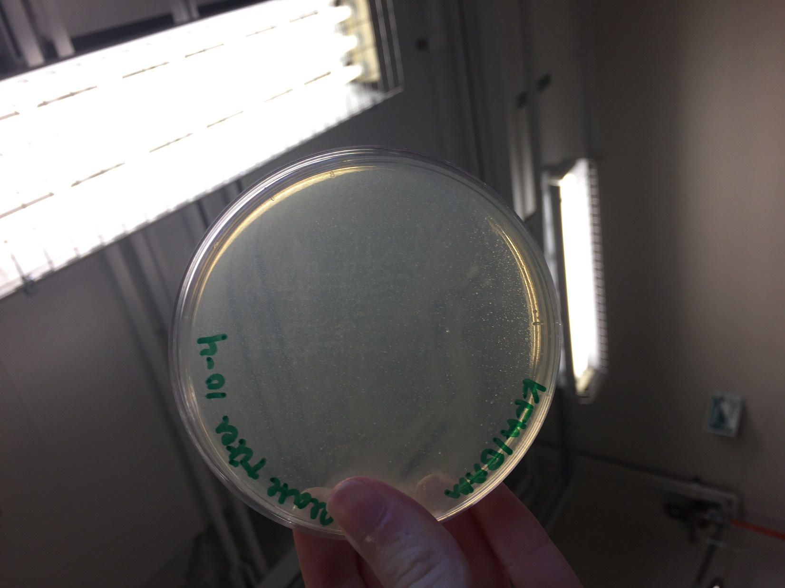

*Figure 49: Full Plate Titer 10^-4*

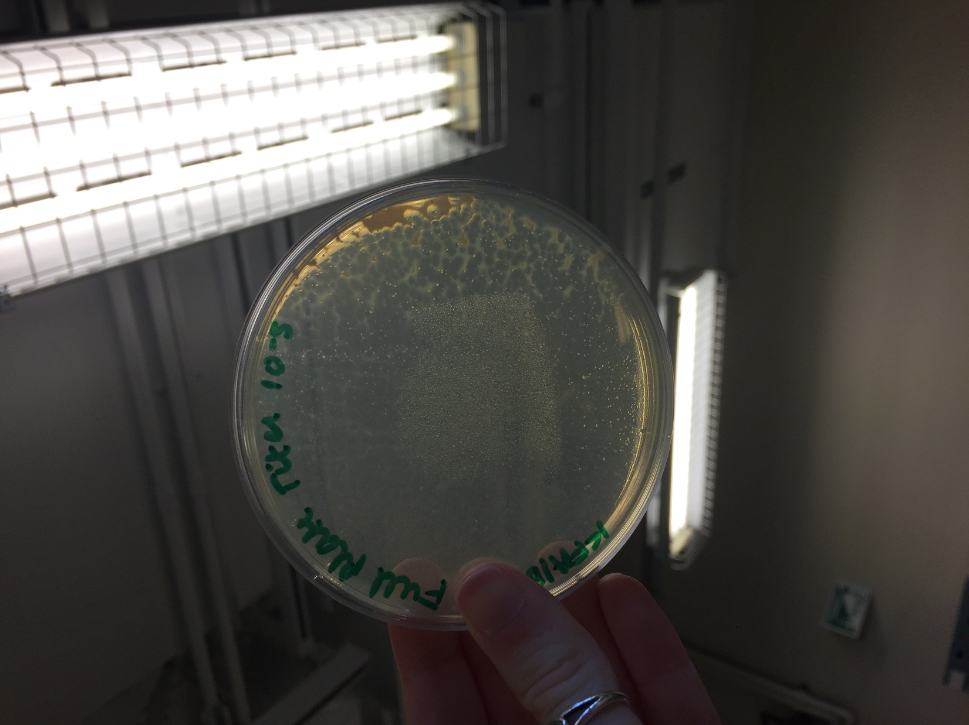

*Figure 50: Full Plate Titer 10^-5*

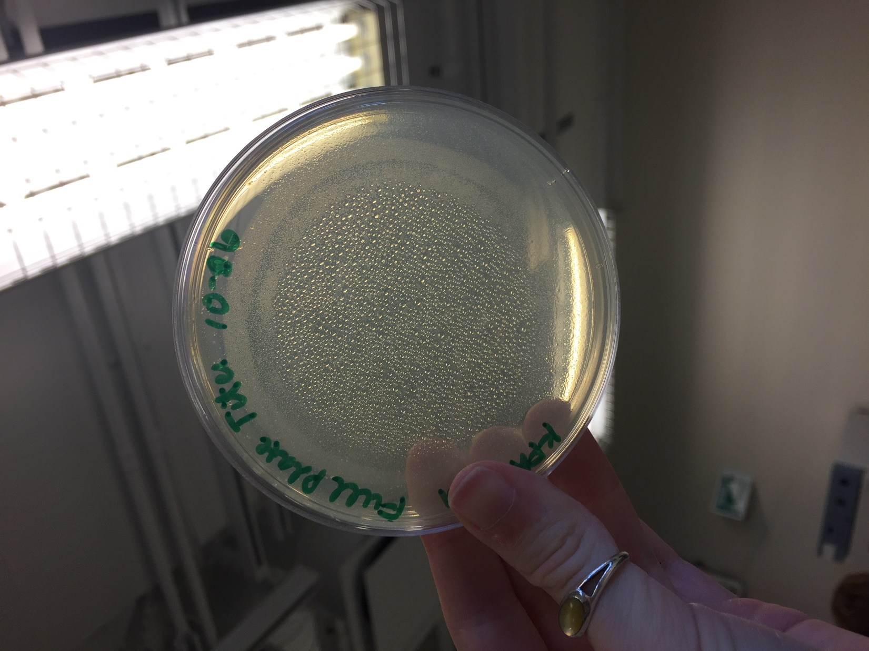

*Figure 51: Full Plate Titer 10^-6*

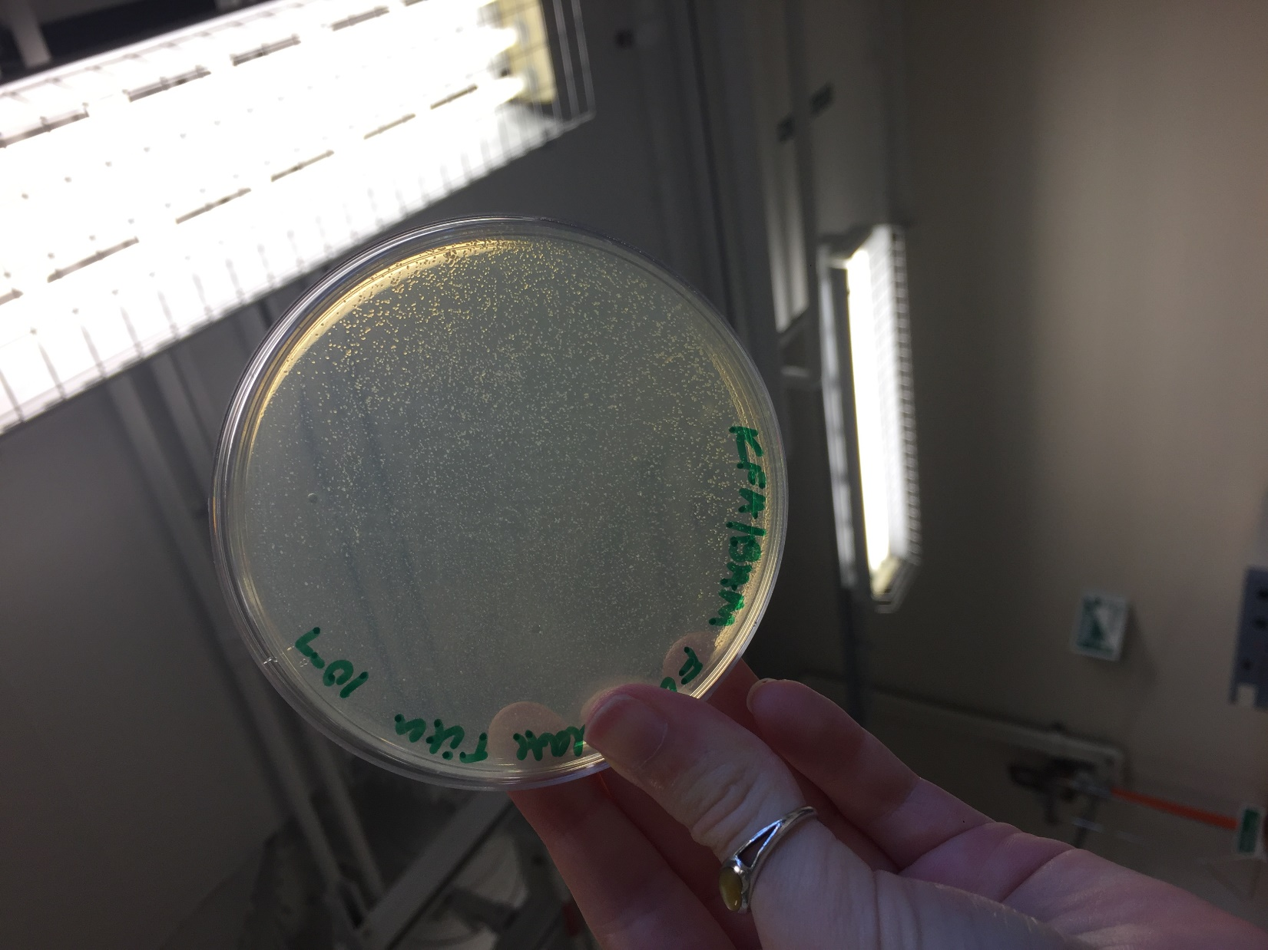

*Figure 52: Full Plate Titer 10^-7*

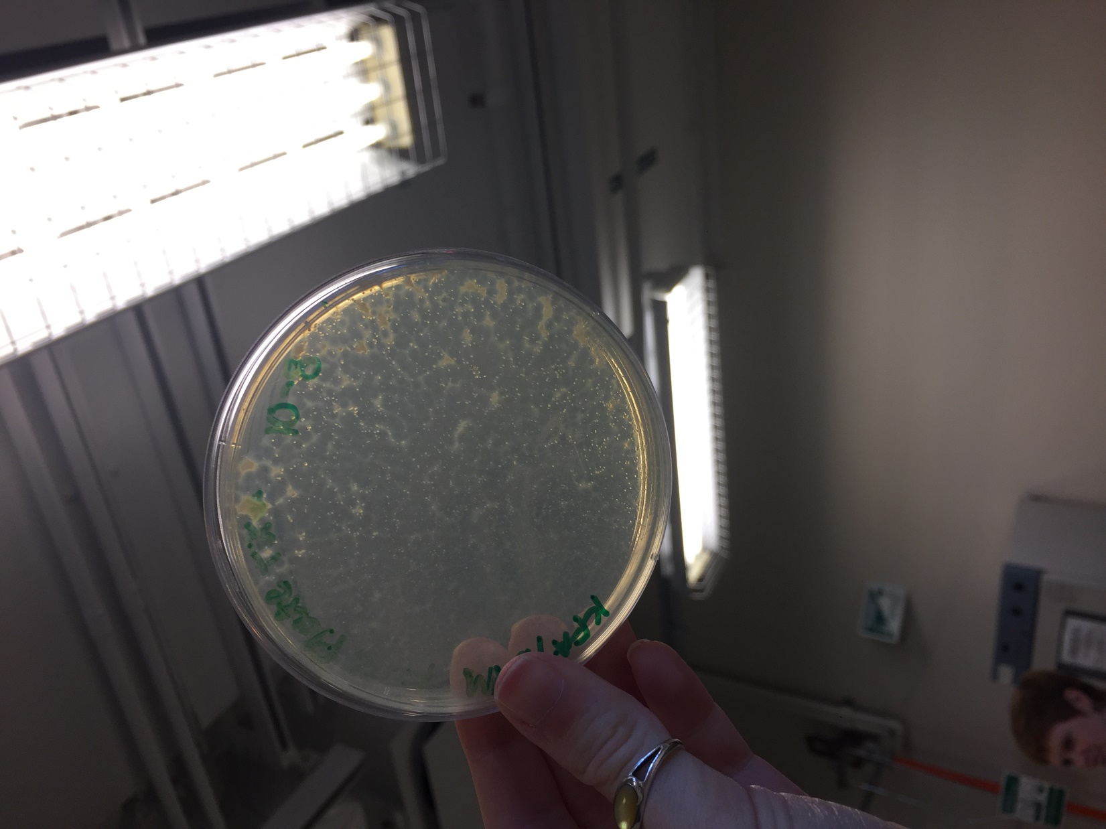

*Figure 53: Full Plate Titer 10^-8*

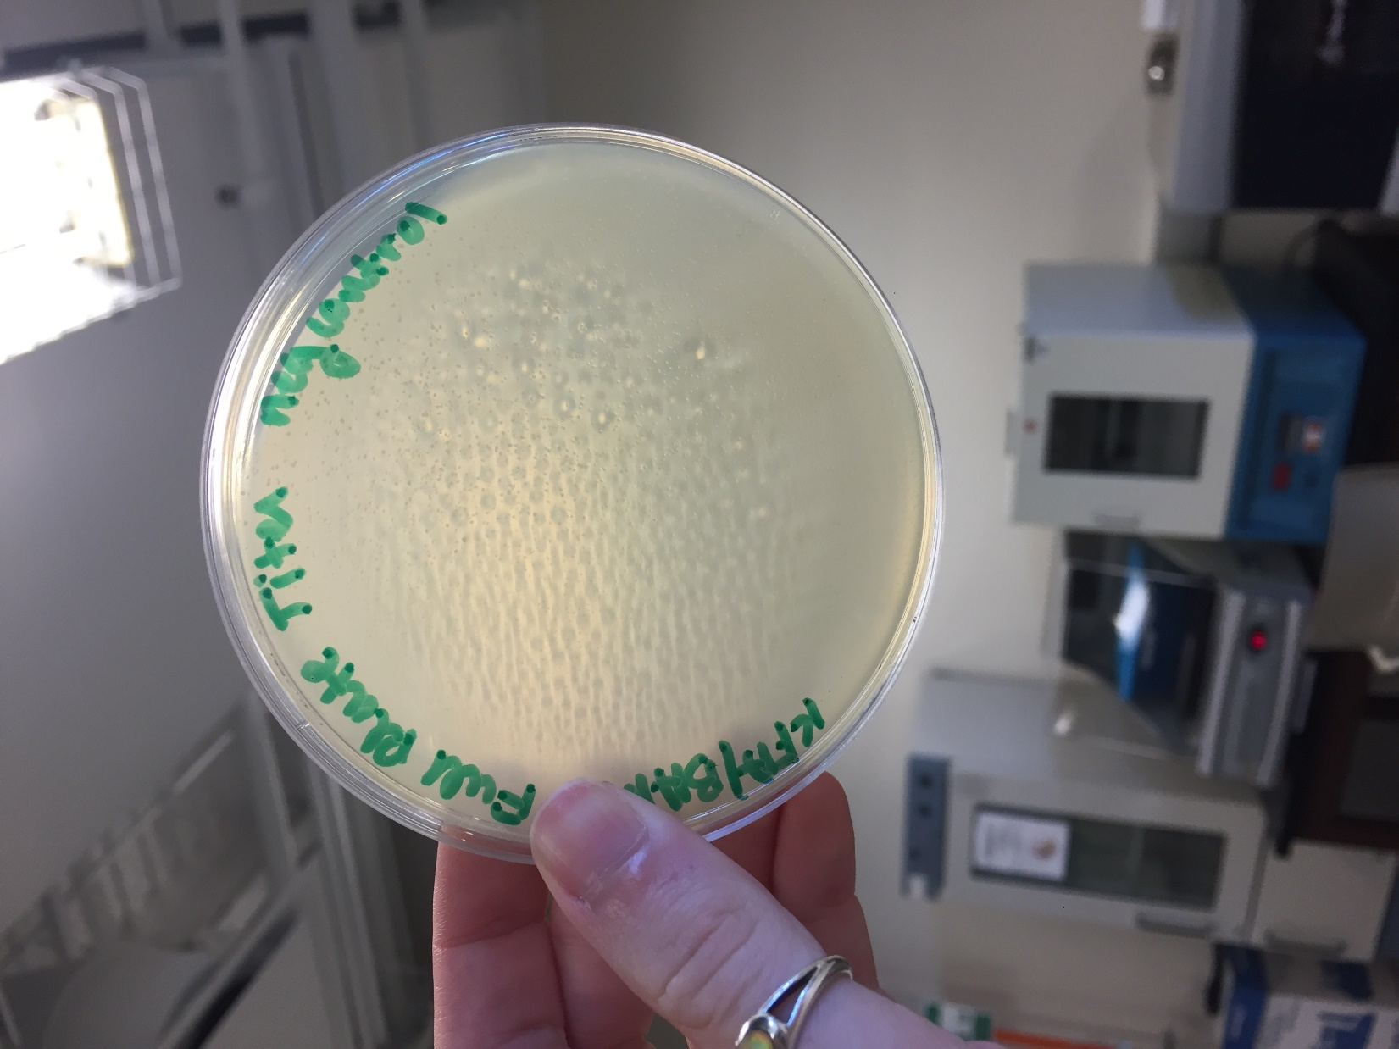

*Figure 54: Full Plate Titer Negative Control*

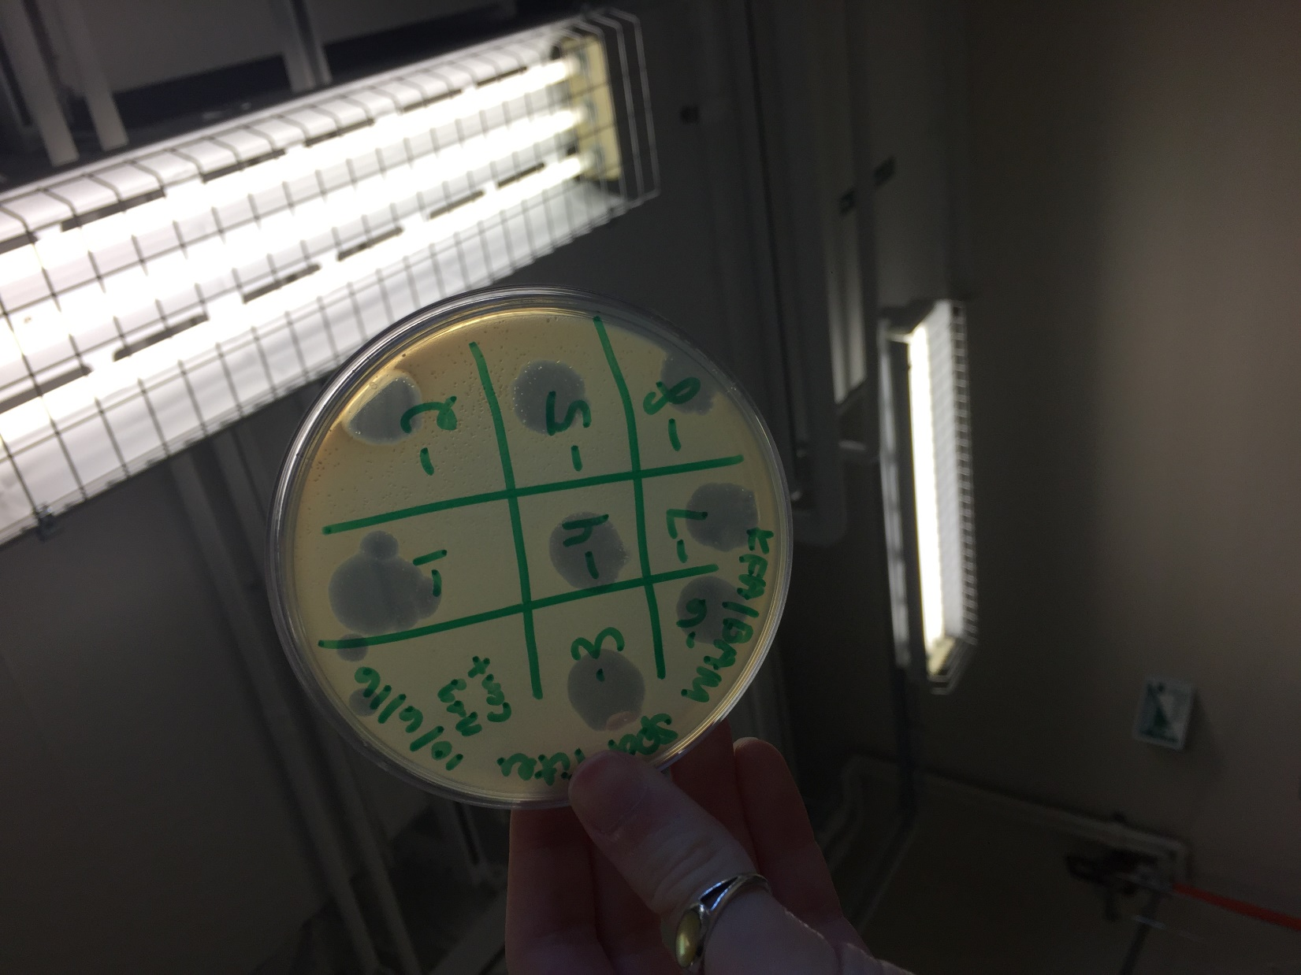

*Figure 55: Spot Plate Titer*

**Future Actions**

* On Tuesday, October 18, 2016 we will inspect the plates made today and determine the titer of the lysate.

Tuesday, October 18, 2016

Tuesday, October 18, 2016

11:30 AM

**Objective**

* Generate well-isolated plaques containing only one kind of phage

**Procedure**

* I followed the Streak Plate procedure
  + I entered lab, washed my hands, put on my goggles, and cleaned my work bench with the brown detergent and ethanol
  + I collected the full plate titers that my partner and I made on Thursday, October 13, 2016.
  + My partner and I inspected the plates and took pictures. (See Data Table 12 and Figures 56 - 62)
    - We found that the concentrations of plaques was slightly illogical, as 10^-8 had fewer plaques than 10^-10 and 10^-12.
    - We also found that the phage created two different morphologies of plaques again, one small, like the size of a pinhead, and one large, about 1/2 centimeter across.
    - After conferring with Stephen and Yi, it was determined that we would follow the Streak Plate process
  + We wrapped up the 10^-12 plate to save it in case the streaking determined that the two plaques came from the same phage.
  + We gathered our materials: our tube rack, three agar plates, three bacterial host cultures, electric pipettors and 5ml tips, and sterile micropipette tips
  + My partner labeled the plates and streaked the negative control plate. I marked where the last streak ended.
  + She picked a large plaque that had been circled on the 10^-8 plate and did the first streak on the large plaque plate
  + She threw the picked tip away into the biohazard, got a new tip, and did the second streak on the large plaque plate, then repeated that procedure for the third streak.
  + I marked where the last streak ended.
  + She then picked a small plaque that had been circled on the 10^-8 plate and did the first streak on the small plaque plate.
  + She threw the picked tip away into the biohazard, got a new tip, and did the second streak on the small plaque plate, then repeated that procedure for the third streak.
  + I marked where the last streak ended and wrapped up the 10^-8 plate to save in case the streaking determined that the two plaques came from the same phage.
  + We ran out of top agar last time, so we got a new top agar jar. My partner labeled it.
  + I used the electric pipettor to take 3 ml of top agar and move it to the bacteria samples. I then threw away the pipette tip and replaced it while my partner vortexed the mixture and poured it over the X in the negative control plate. This procedure was repeated for the other two plates.
  + We put away all our supplies, cleaned our work bench, and I washed my hands.

**Data**

*Table 12: Full Plate Titer Observations*

|  |  |
| --- | --- |
| Plate | Observations |
| Negative control | Some small air bubbles, but no plaques nor contamination |
| 10^-2 | Totally cleared of all bacteria |
| 10^-4 | Totally cleared of all bacteria |
| 10^-6 | Nearly entirely clear of all bacteria; some small webbing in one area of the plate |
| 10^-8 | A countable number of plaques; some large (about 1/2 cm across), and some small (the size of a pinhead) |
| 10^-10 | 2/3rds are clear of bacteria, the last third has a countable number of plaques, some large, and some small |
| 10^-12 | One side has an uncountable number of plaques, as they run together; the other side has a countable number of plaques, some large and some small |

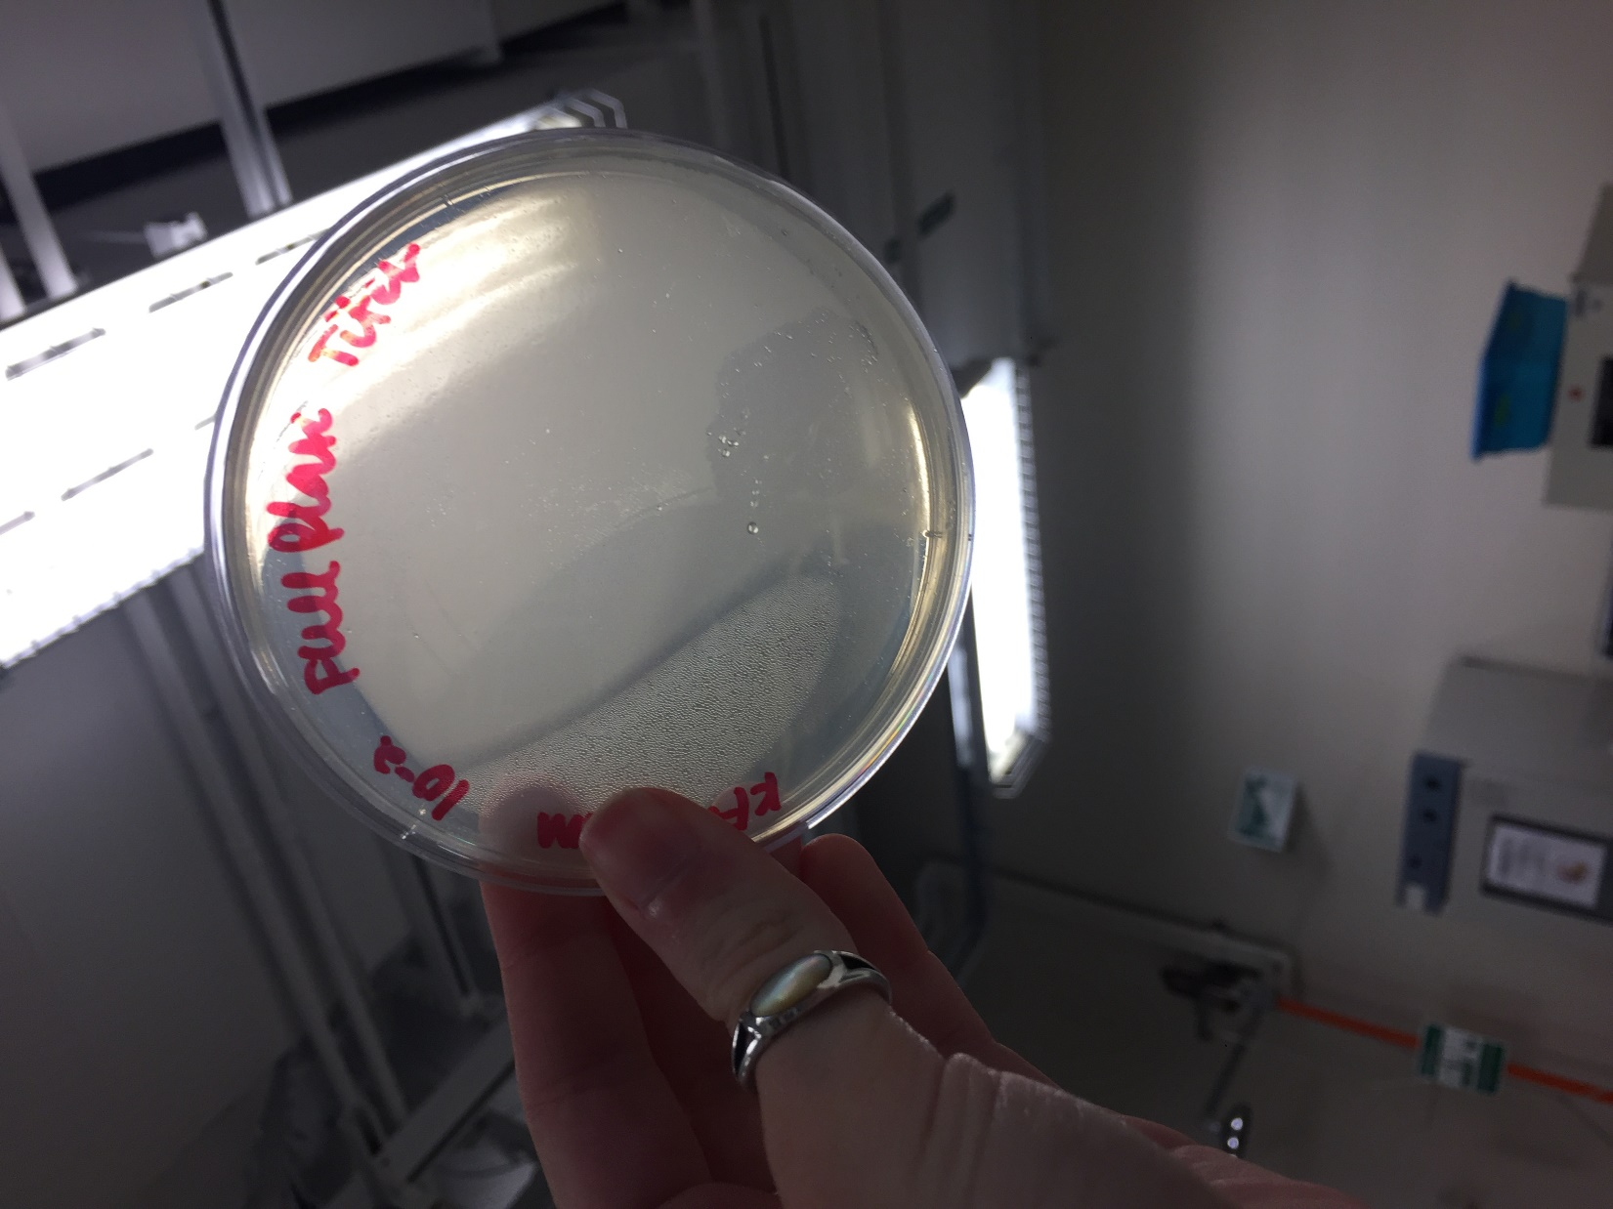

*Figure 56: Full Plate Titer, 10^-2*

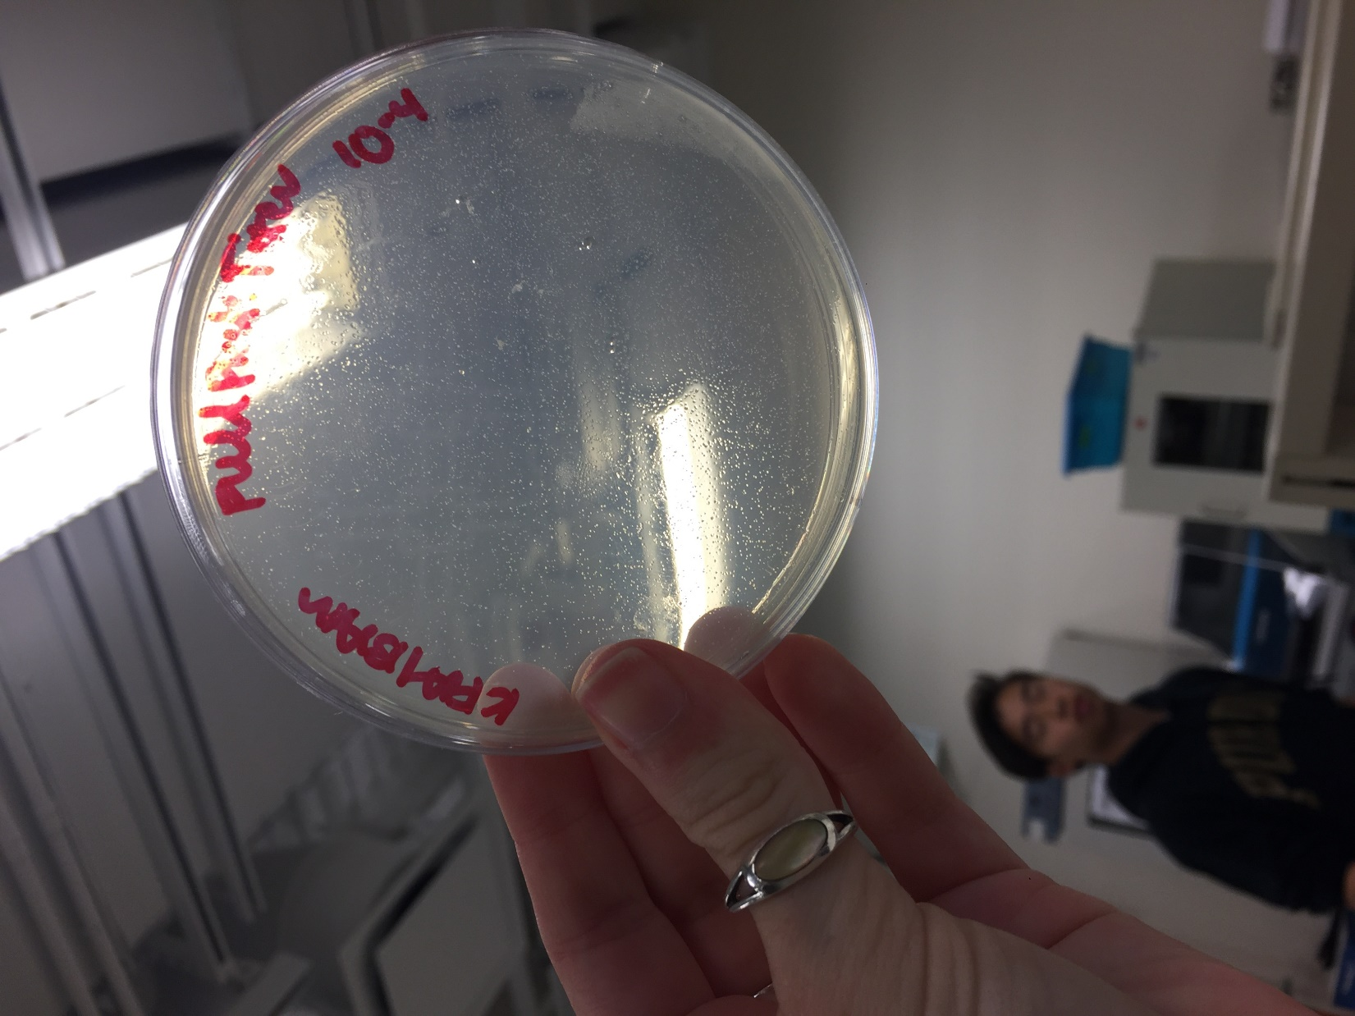

*Figure 57: Full Plate Titer, 10^-4*

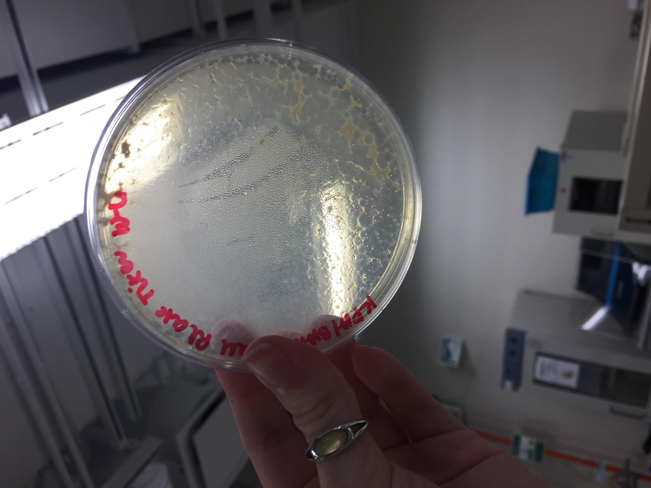

*Figure 58: Full Plate Titer: 10^-6*

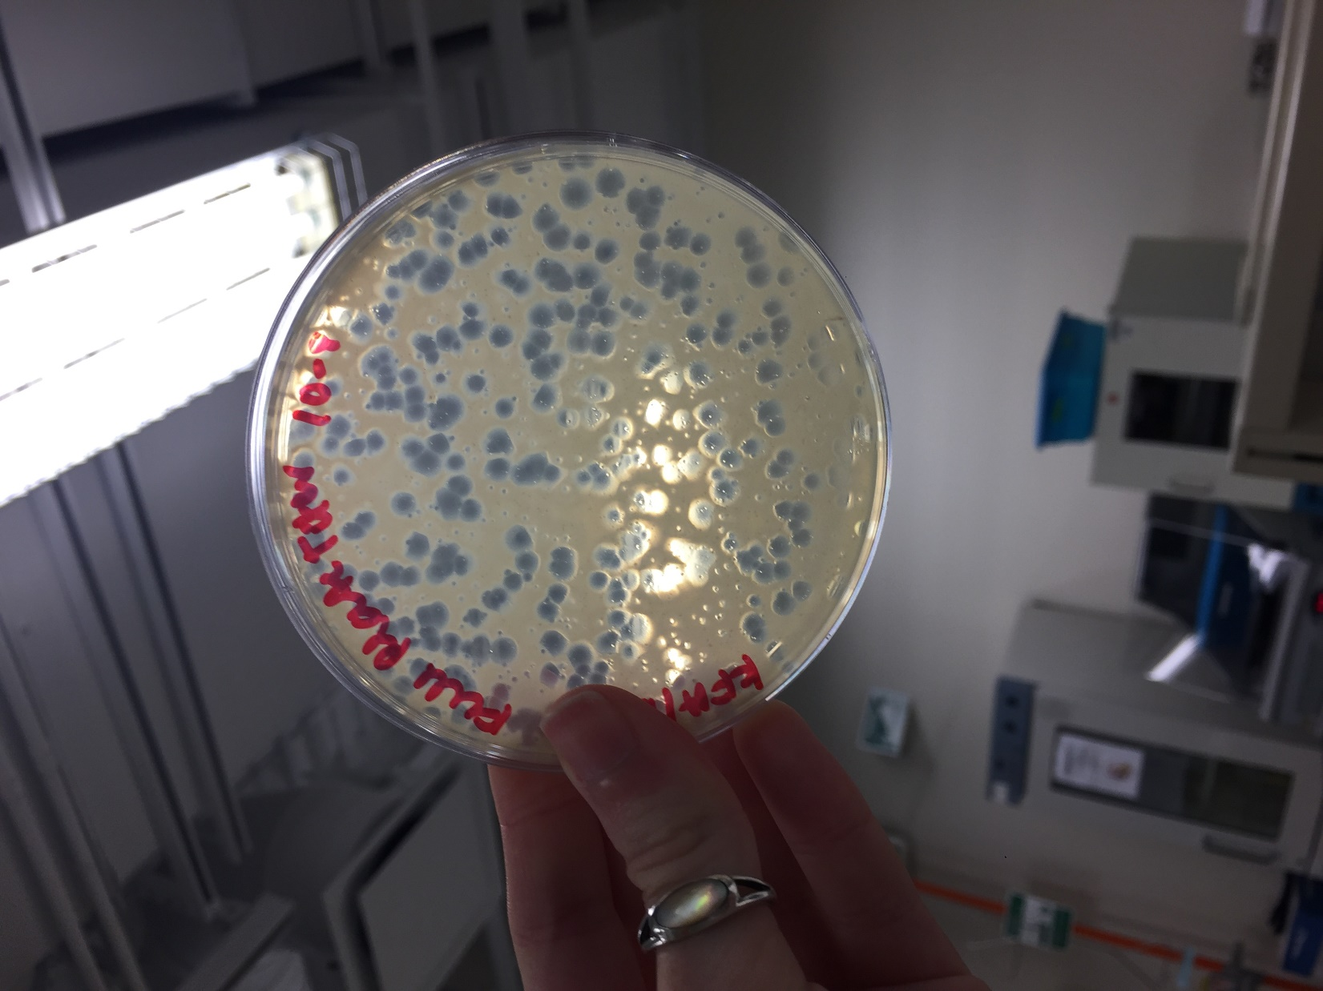

*Figure 59: Full Plate Titer 10^-8*

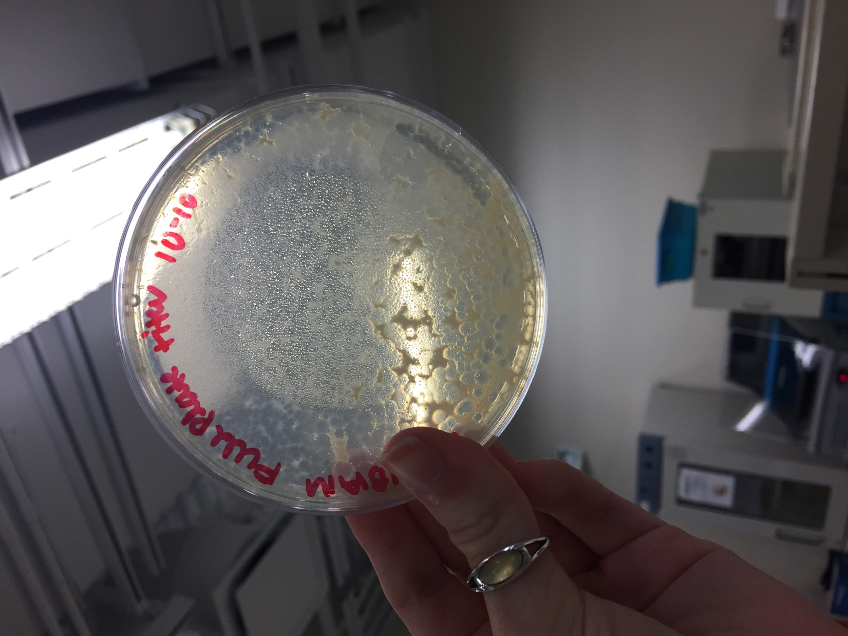

*Figure 60: Full Plate Titer, 10^-10*

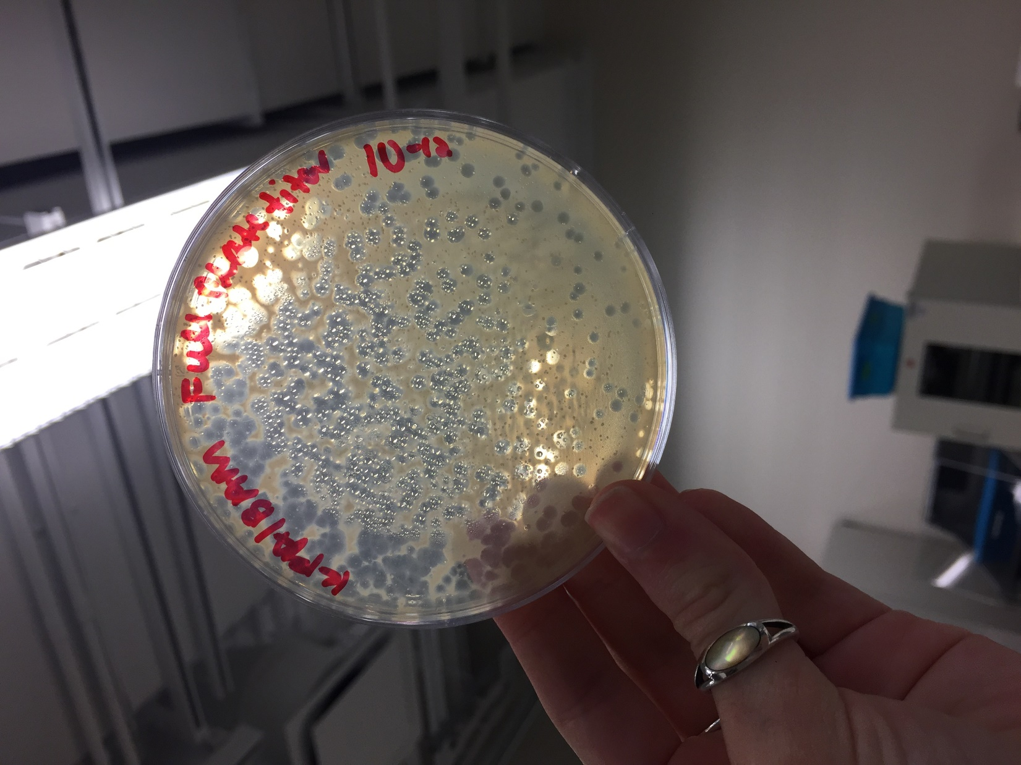

*Figure 61: Full Plate Titer, 10^-12*

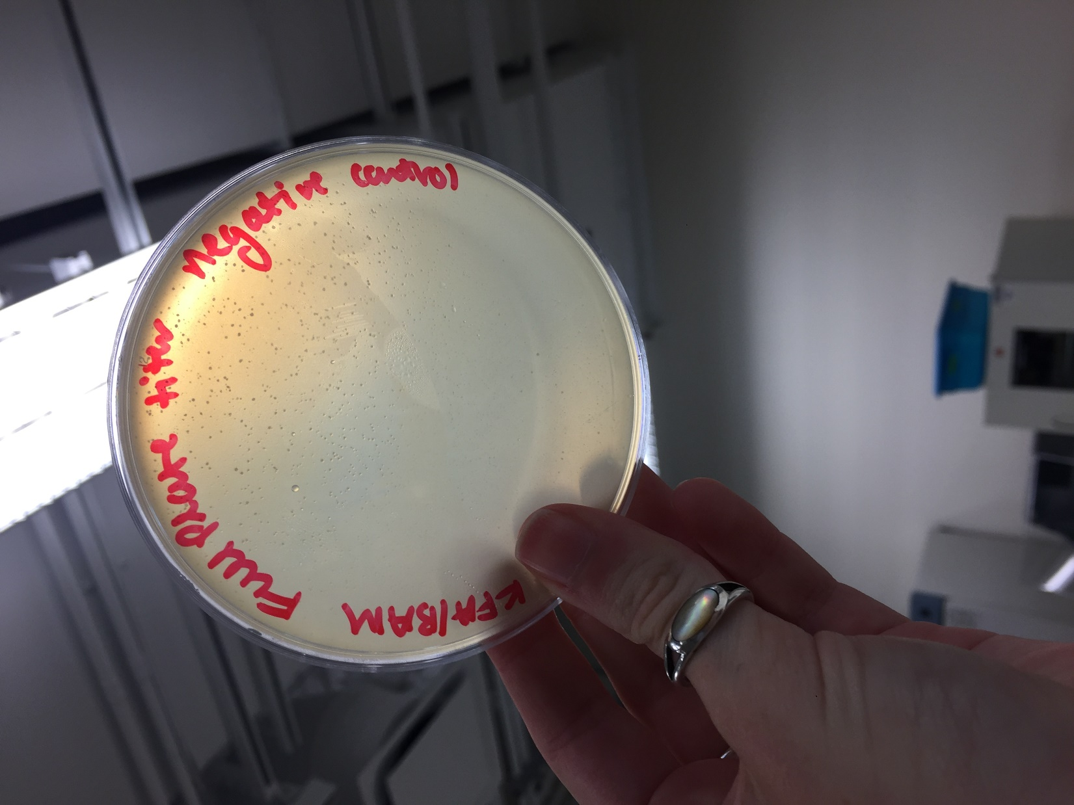

*Figure 62: Full Plate Titer, negative control*

**Future Actions**

* On Thursday, October 20, 2016, the streak plates will be examined to see if the plaques come from the same phage.
* If they do come from the same phage, the titer of the lysate used to create the full plate titers will be calculated.
* If not, one of the two phage morphologies will be picked and serially diluted to create new bacterial lawns.

Thursday, October 20, 2016

Thursday, October 20, 2016

11:30 AM

**Objective**

* Isolate and test phage to determine if identified plaques contained phage
* To prepare liquid phage samples of decreasing concentrations
* Prepare sample for plating and incubation

**Procedure**

* Today I followed the picking a plaque, serial dilution, and plating a sample procedures
  + I walked into lab and found that my lab bench had been used to set up the gel electrophoresis last class.
  + A TA instructed me to switch benches so as not to disturb the setup
  + I washed my hands, cleaned my workbench with ethanol and the brown detergent, and retrieved the streak plates my partner and I had made last time.
  + We analyzed the plates, took note of our observations, and took pictures of the plates. (See Table 13 & Figures 64-66).
    - We found that the small plaque streak plate had both morphologies of plaque that we had found last time and the large plaque streak plate only had the large plaque morphology.
    - Thus, we determined that we would have to start over with just the large plaque and make serial dilutions.
  + My partner and I gathered the materials we would need for the day.
  + I filled the microcentrifuge tubes with 90 microL of phage buffer while my partner labeled the bacterial samples and the agar plates we would be using today.
  + I labeled the plaque I wanted to pick and then used a micropipettor tip to pick the plaque.
  + My partner held and opened the microcentrifuge tubes near the flame while I performed the serial dilutions.
  + I then infected the bacteria samples with the help of my partner opening and closing the microcentrifuge tubes and bacteria sample tubes.
  + After waiting 10 minutes, my partner retrieved the agar. I opened the bacteria samples for her to deposite 3ml of agar into each of them, and then I plated the agar-bacteria mix.
  + We wrapped the plate in case we need to pick another plaque from it next time.
  + We put everything away, cleaned our workbench, and washed our hands.

**Data**

*Table 13: Streak Plate Observations*

|  |  |
| --- | --- |
| Plate | Observations |
| Negative control | No plaques, but a cleared area due to agar not reaching every corner of the plate |
| Large plaque | Many plaques along the first streak, a few along the second streak, and none along the third streak. The plaques are all round and about 1/2 cm across |
| Small plaque | Many plaques along the first streak, a few along the second streak, and none along the third streak. There are two morphologies -- some small like pinheads, and some larger, about 1/3-1/2 cm across. |

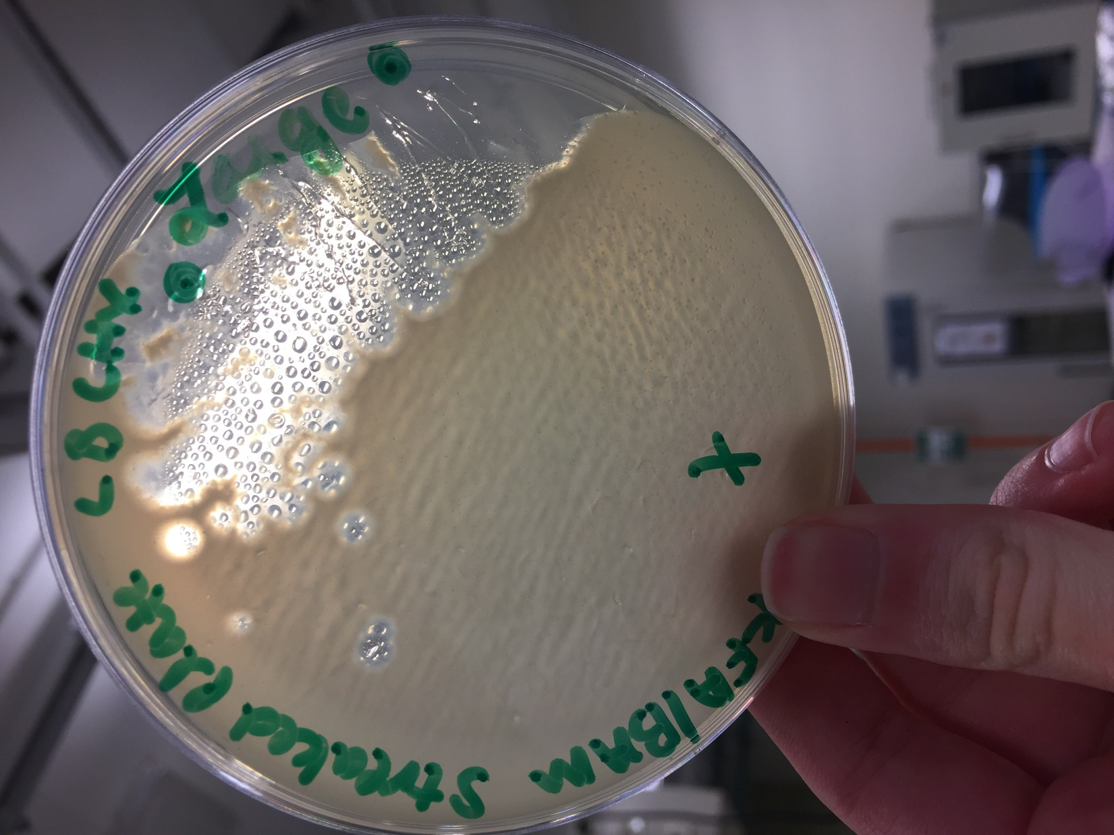

*Figure 64: Streak Plate, Large Plaque*

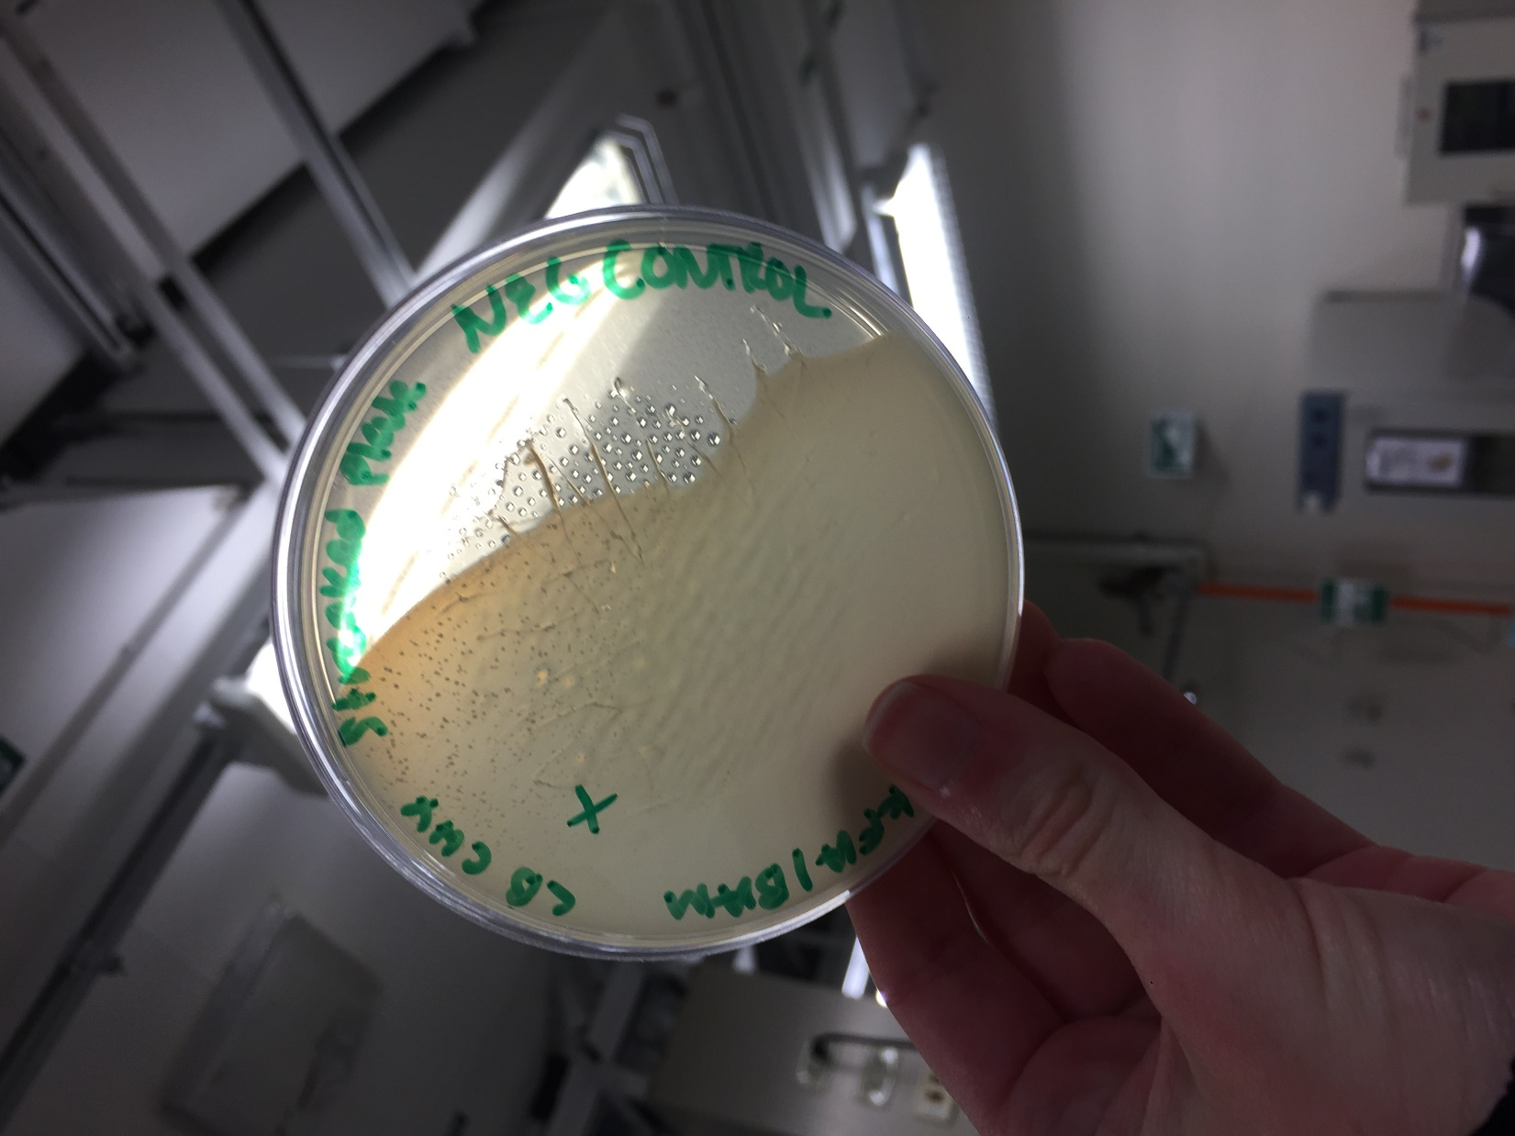

*Figure 65: Streak Plate, Negative Control*

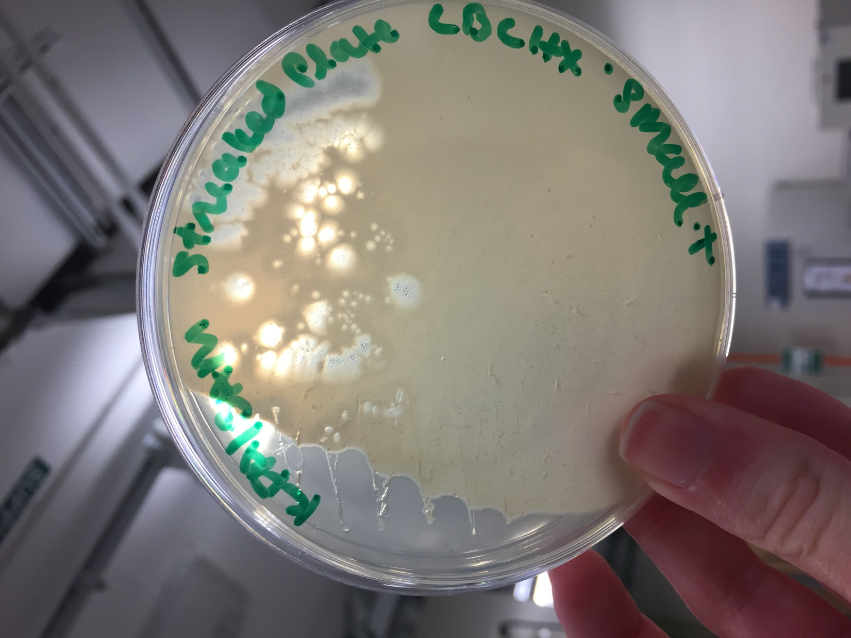

*Figure 66: Streak Plate, Small Plaque*

**Future Actions**

* On Tuesday, October 25, 2016, we will inspect the serial dilution plates.
* If the serial dilution produced a webbed plate and a logical decrease in concentration of plaques, we will flood our best plate.
* If not, we will repeat the procedure done today with a different plaque on the large plaque streak plate that we saved today.

Tuesday, October 25, 2016

Tuesday, October 25, 2016

11:30 AM

**Objective**

* Determine if plaques have grown from the picked plaque
* Generate a highly concentrated liquid phage sample

**Procedure**

* I followed the flooding a plate protocol.
  + I walked into lab, washed my hands, and cleaned off my lab bench.
  + I collected the plates my group had made last week.
  + My partner and I inspected the plates, recorded our observations, and took pictures of the plates. (See Table 14 & Figures 67-75).
  + I collected the materials we would need for the day.
  + We then flooded our 10^-1, 10^-2, and 10^-3 plates and scheduled an appointment with Stephen for Wednesday, October 26, 2016 at 9:30 am to collect our plate lysates.
  + We wrapped our plates to save them from spilling.
  + We cleaned our workspace off and then washed our hands.

**Data**

*Table 14: Serial Dilution Observations*

|  |  |
| --- | --- |
| Plate | Observations |
| Negative control | No plaques or contamination. A few small air bubbles the size of pin heads. |
| 10^-1 | Nearly completely clear of bacteria. A few light "cloudy" areas scattered throughout the plate. Many small air bubbles the size of pin heads. |
| 10^-2 | Very obvious webbing on one half of the plate. The other half is less obviously webbed. It looks like condensation on the plate surface, but is definitely bacteria. |
| 10^-3 | Webbed plate, one half has countable plaques, the other half is more webbed than not and harder to count. |
| 10^-4 | A countable number of plaques. Plaques are nearly perfectly round, about 1/2 centimeter across, and clear inside (little to no cloudiness). |
| 10^-5 | About 50-75 plaques. Plaques are nearly perfectly round, about 1/2 centimeter across, and have little to no cloudiness. |
| 10^-6 | About 20 plaques. Plaques are nearly perfectly round, about 1/2 centimeter across, and have little to no cloudiness. |
| 10^-7 | One edge of the plate is not coated in agar. 9 plaques that are nearly perfectly round, about 1/2 centimeter across, and have little to no cloudiness. |
| 10^-8 | 4 plaques that are nearly perfectly round, about 1/2 centimeter across, and have little to no cloudiness |

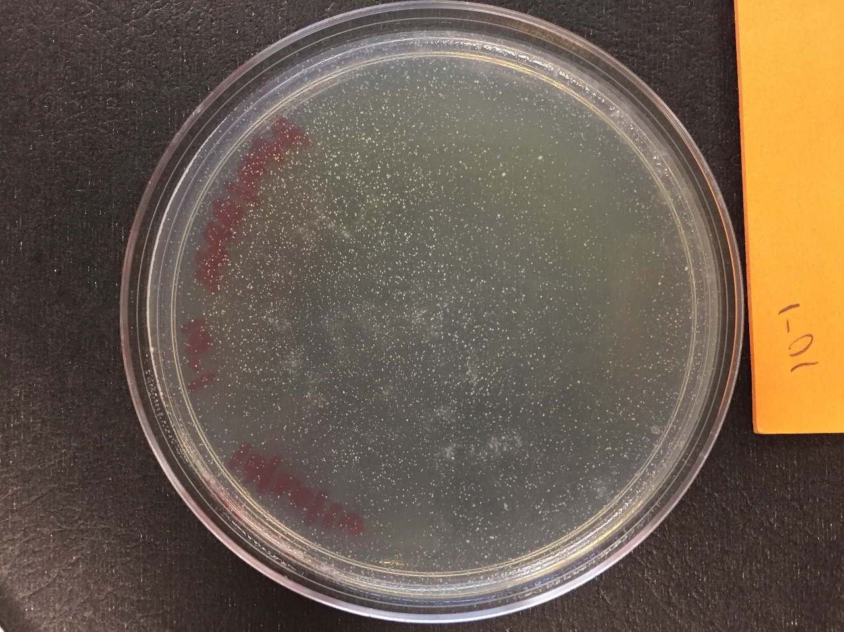

*Figure 67: Serial Dilution, 10^-1*

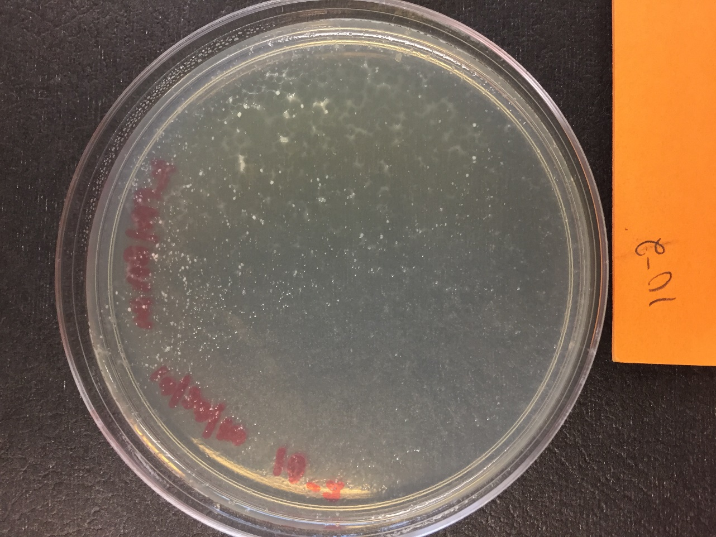

*Figure 68: Serial Dilution, 10^-2*

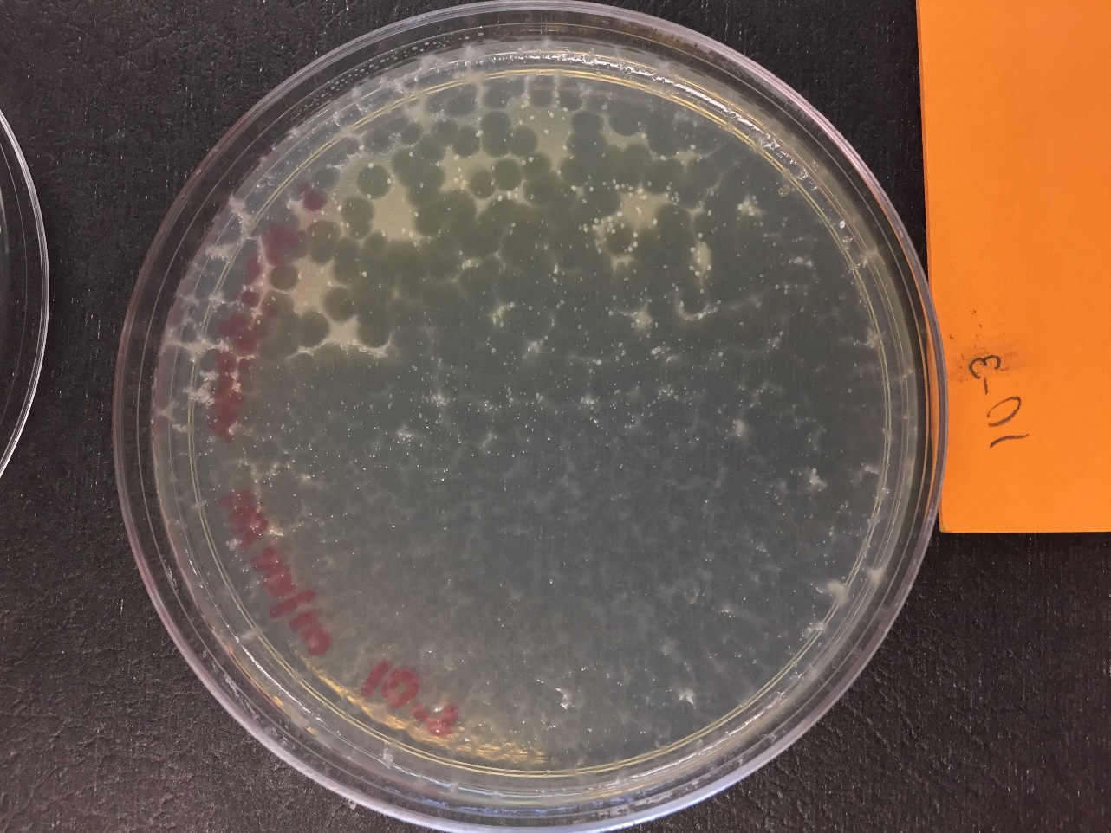

*Figure 69: Serial Dilution, 10^-3*

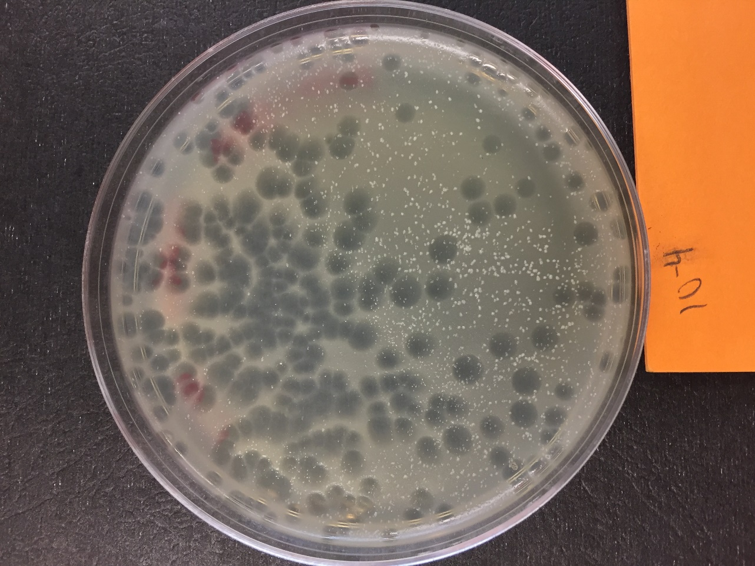

*Figure 70: Serial Dilution, 10^-4*

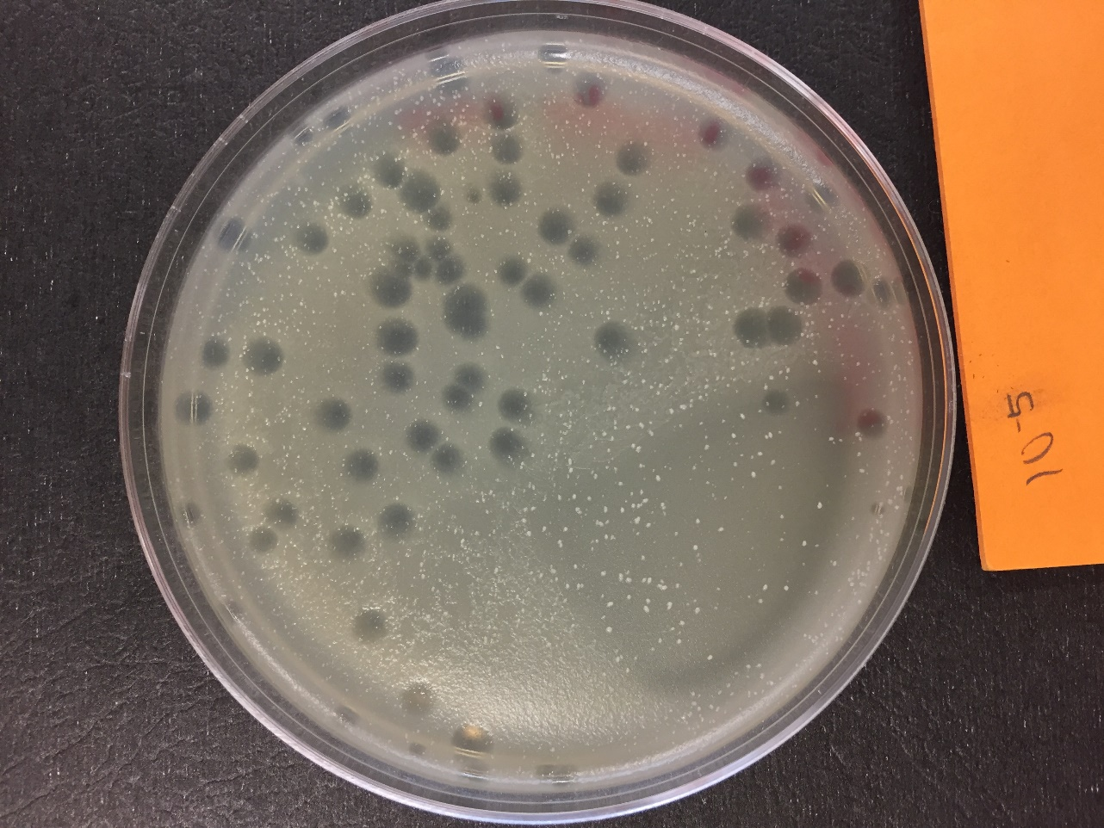

*Figure 71: Serial Dilution, 10^-5*

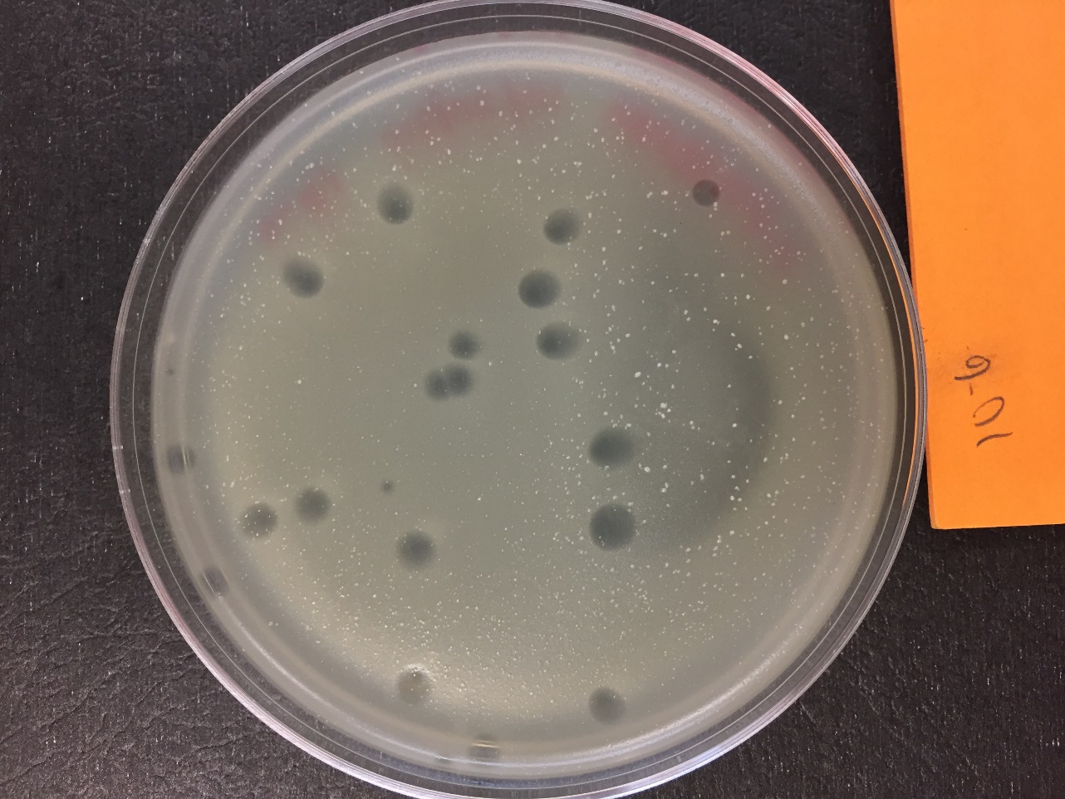

*Figure 72: Serial Dilution, 10^-6*

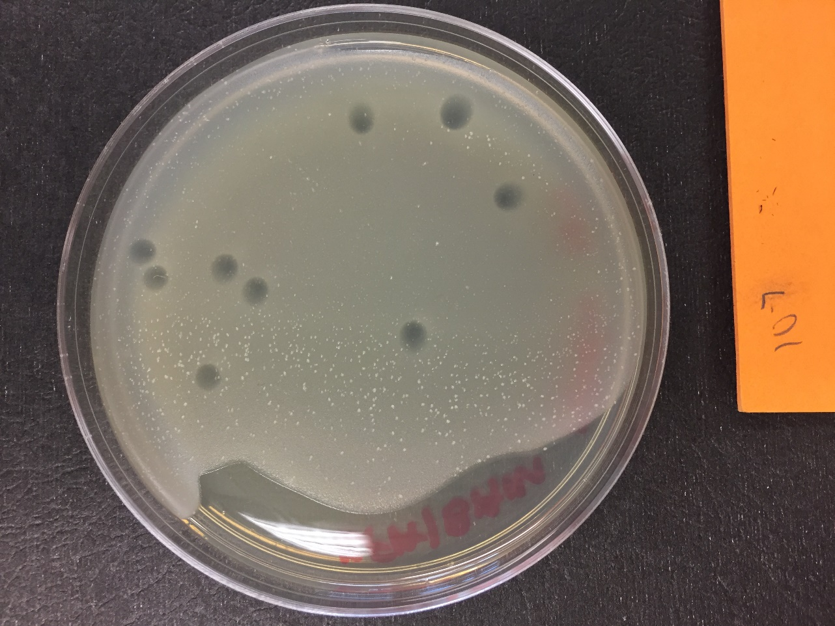

*Figure 73: Serial Dilution 10^-7*

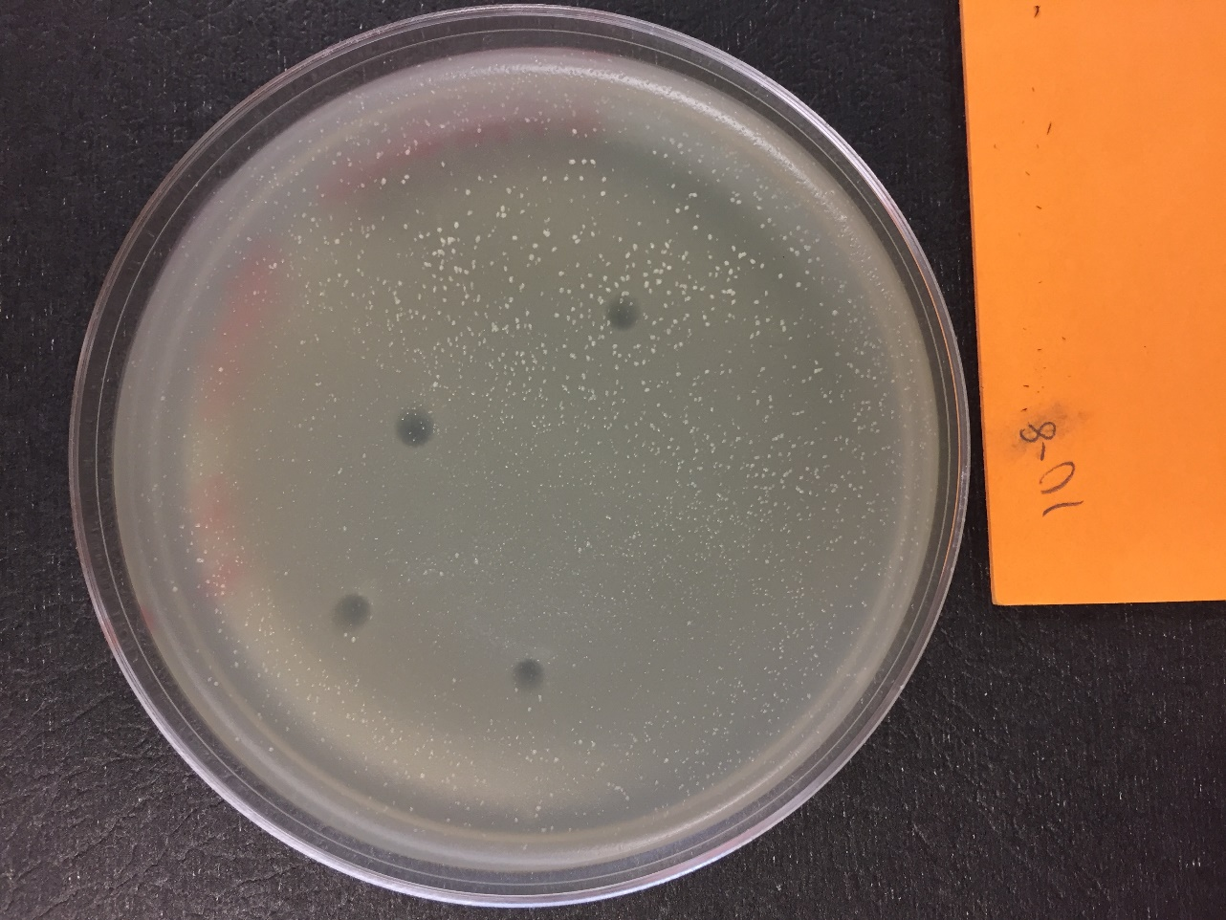

*Figure 74: Serial Dilution 10^-8*

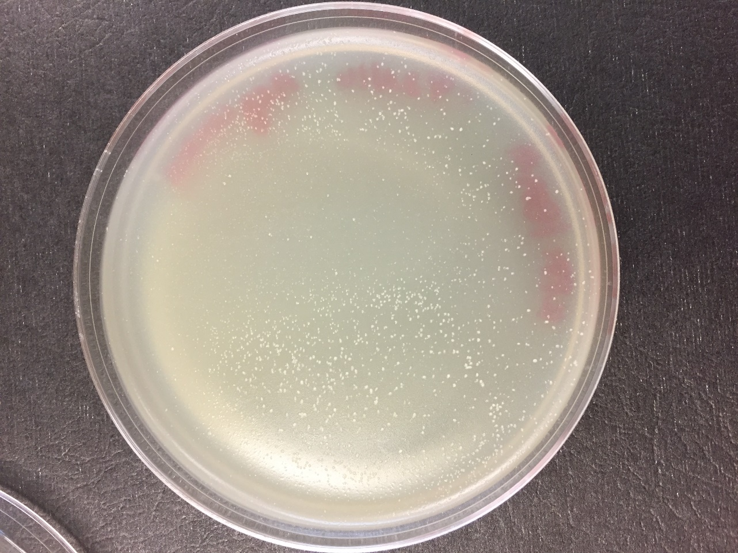

*Figure 75: Serial Dilution, Negative Control*

**Future Actions**

* On Wednesday, October 26, 2016 at 9:30 am, my partner and I will collect the lysate from the three plates we flooded today with the help of Stephen.

Wednesday, October 26, 2016

Wednesday, October 26, 2016

9:30 AM

**Objective**

* Collect a highly concentrated liquid phage sample

**Procedure**

* I followed the collecting a lysate protocol.
  + I walked into lab, washed my hands, and cleaned off my lab bench.
  + My partner labeled the 15 ml conical tube that would hold our lysate
  + I unwrapped the sterile filter and syringe.
  + I held the filter wrapper as my partner took up the lysate from the plates, screwed the syringe into the filter, filtered the lysate through the filter, then unscrewed the filter off of the syringe back into the wrapper, and then repeated the process.
  + Stephen took our lysate and stored it in the fridge.
  + We cleaned our workspace off and then washed our hands.

**Data**

We collected 15 ml of lysate from the three flooded plates.

**Future Actions**

On Thursday, October 27, 2016, my partner and I will create spot and full plate titers to determine the titer of our lysate.

Thursday, October 27, 2016

Thursday, October 27, 2016

11:30 AM

**Objective**

* To prepare liquid phage samples of decreasing concentrations
* Determine the concentration of phage particles in a lysate using a spot test and plaque assay
* Prepare sample for plating and incubation

**Procedure**

* I followed the serial dilution, spot titer and full plate titer, and plating a sample protocols.
  + I walked into lab, washed my hands, and cleaned off my work bench.
  + I got the lysate collected yesterday while my partner retrieved the other items we would need for the day and labeled the plates we would be using.
  + We got the agar, mixed 3 ml of it with a bacterial sample, and created our spot titer plate.
  + While allowing the agar to harden, we performed the serial dilution from 10^-1 to 10^-8
    - In between 10^-2 and 10^-3, the tip of the micropipettor bent, so we changed tips
  + We infected the bacteria to be used for the full plate titers with 10 microL of the serial dilutions.
  + We performed the spot titer on the bacterial lawn
    - There were no issues with the levelness of the agar, and no drops of serially diluted lysate moved to a location that they did not belong to.
  + After waiting five more minutes, we plated the full plate titers.
  + We then cleaned our work bench and washed our hands.

**Future Actions**

* On Tuesday, November 1, 2016, we will inspect the spot and full plate titer plates made today and determine the titer of our lysate.
* If our titer is high enough, we may go directly into DNA extraction, as we have a high volume of lysate.
* If not, we will flood three or more of our plates to generate a new lysate, and then go on to determine that lysate's titer.

Tuesday, November 1, 2016

Tuesday, November 1, 2016

11:30 AM

**Objective**

* To calculate the titer of the lysate

**Procedure**

* I continued the spot and full plate titer protocol today
  + I walked into lab, washed my hands, washed my work bench, and collected the plates my group had made last time
  + My partner and I examined the plates, noted our observations, and took photos of the plates (See Data Tables 15-16 & Figures 76-85).
  + We counted the number of plaques on the 10^-7 and 10^-8 dilution plates
  + We determined that the titer of the lysate is 1.01 * 10^11
  + We wrapped our 10^-1 to 10^-5 plates to save for next time
  + We cleaned up our work bench and washed our hands

**Data**

*Table 15: Full Plate Titer Observations*

|  |  |  |
| --- | --- | --- |
| Plate | Observations | Titer Calculated |
| Negative Control | There are not any plaques, just pin-head sized air bubbles | N/A |
| 10^-1 | Plate completely clear of bacteria | N/A |
| 10^-2 | Plate completely clear of bacteria | N/A |
| 10^-3 | Plate completely clear of bacteria | N/A |
| 10^-4 | Plate nearly completely clear of bacteria, very small spot of webbing | N/A |
| 10^-5 | Plate nearly completely clear of bacteria, very small spots of webbing | N/A |
| 10^-6 | Plate has about 300-500 plaques, about 1/2 centimeter across, nearly perfectly round, very clear inside | N/A |
| 10^-7 | 101 plaques about 1/2 centimeter across, nearly perfectly round, very clear inside | 1.01 * 10^11 |
| 10^-8 | 26 plaques about 1/2 centimeter across, nearly perfectly round, very clear inside | 2.6 * 10^11 |

*Table 16: Spot Titer Observations*

|  |  |
| --- | --- |
| Spot | Observations |
| Negative control | Two round plaques about 1/2 centimeter across, very clear inside. Probably spread from adjacent spots, rather than being errors, as the full plate titer does not have any plaques |
| 10^-1 | One large plaque about 1/2 inch across, very clear inside |
| 10^-2 | One large plaque about 1/3 inch across, very clear inside |
| 10^-3 | One large plaque about 1/3 inch across, very clear inside |
| 10^-4 | Two plaques, one about 1/2 centimeter across, the other about 1/4 inch across, both clear inside |
| 10^5 | One plaque about 1/4 inch across, clear inside |
| 10^-6 | Two plaques, one about 1/2 centimeter across, the other about 1/4 inch across, clear inside |
| 10^-7 | One plaque about 1/4 inch across, clear inside |
| 10^-8 | 5 small plaques about 1/2 centimeter across |

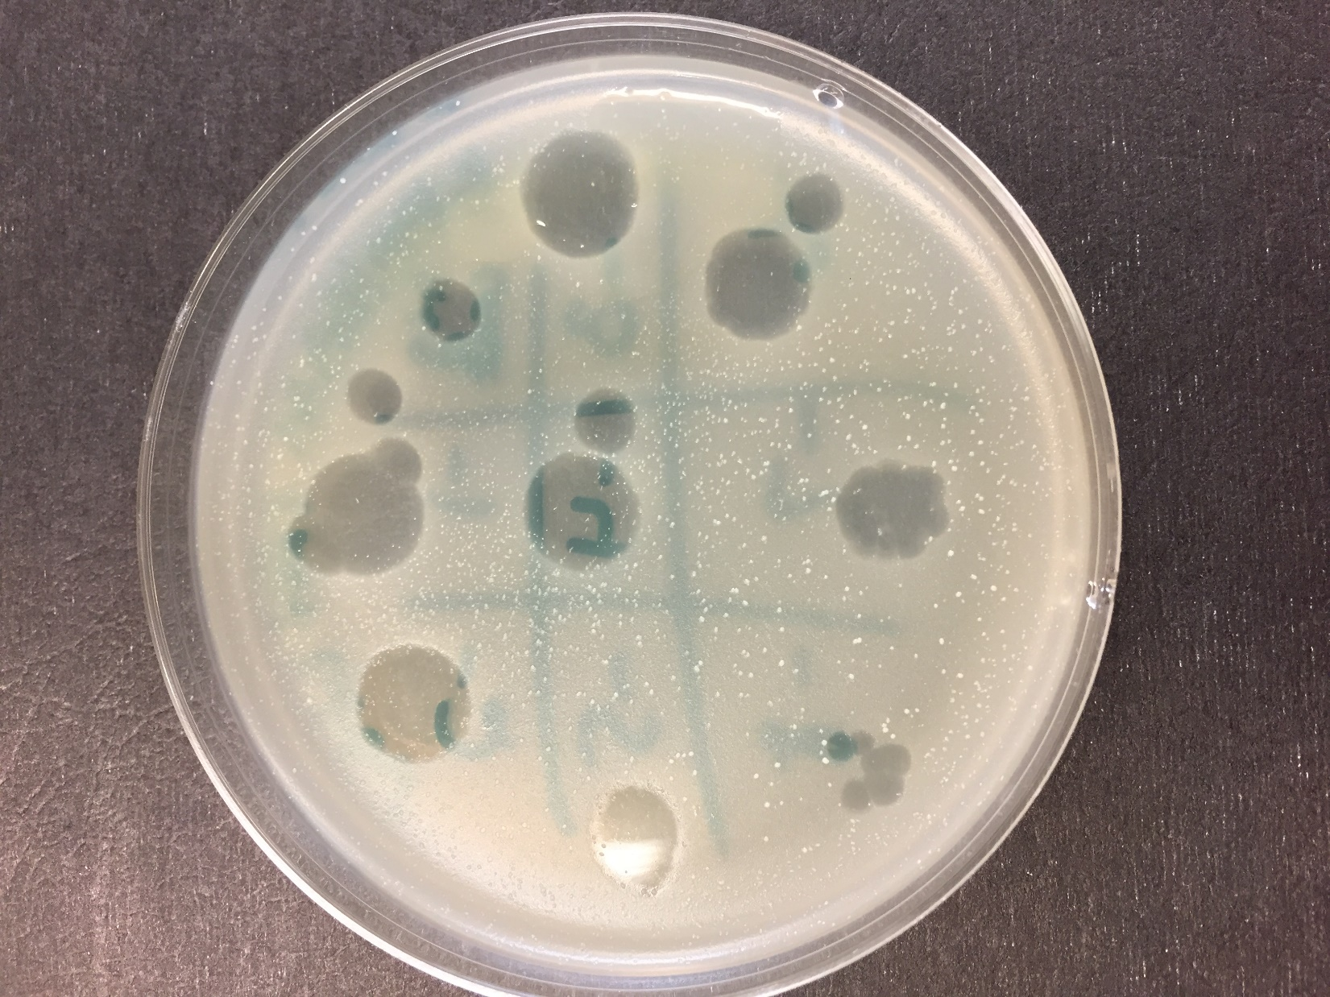

*Figure 76: Spot Titer Plate*

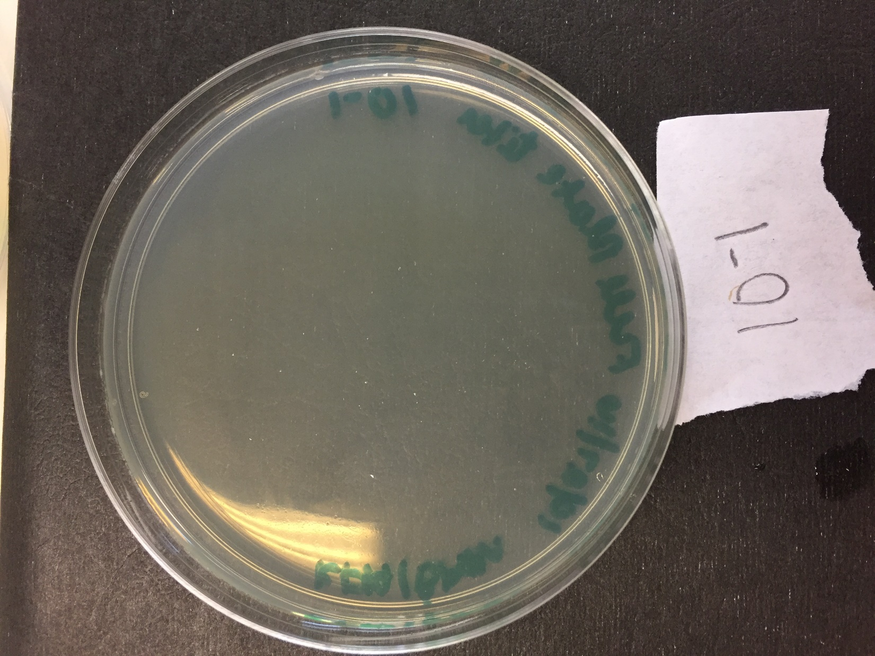

*Figure 77: Full Plate Titer, 10^-1*

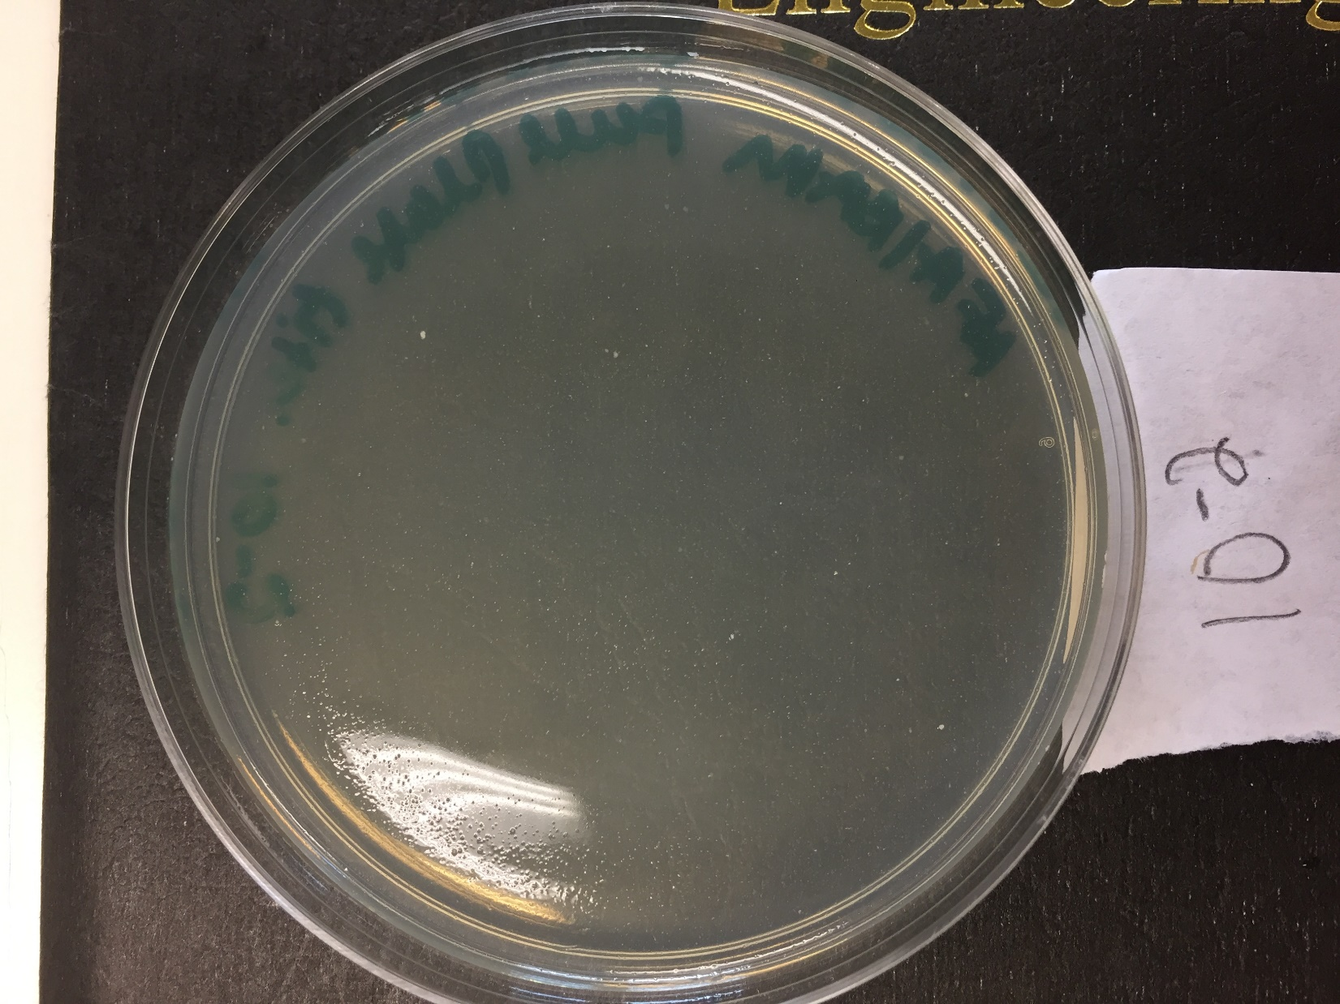

*Figure 78: Full Plate Titer, 10^-2*

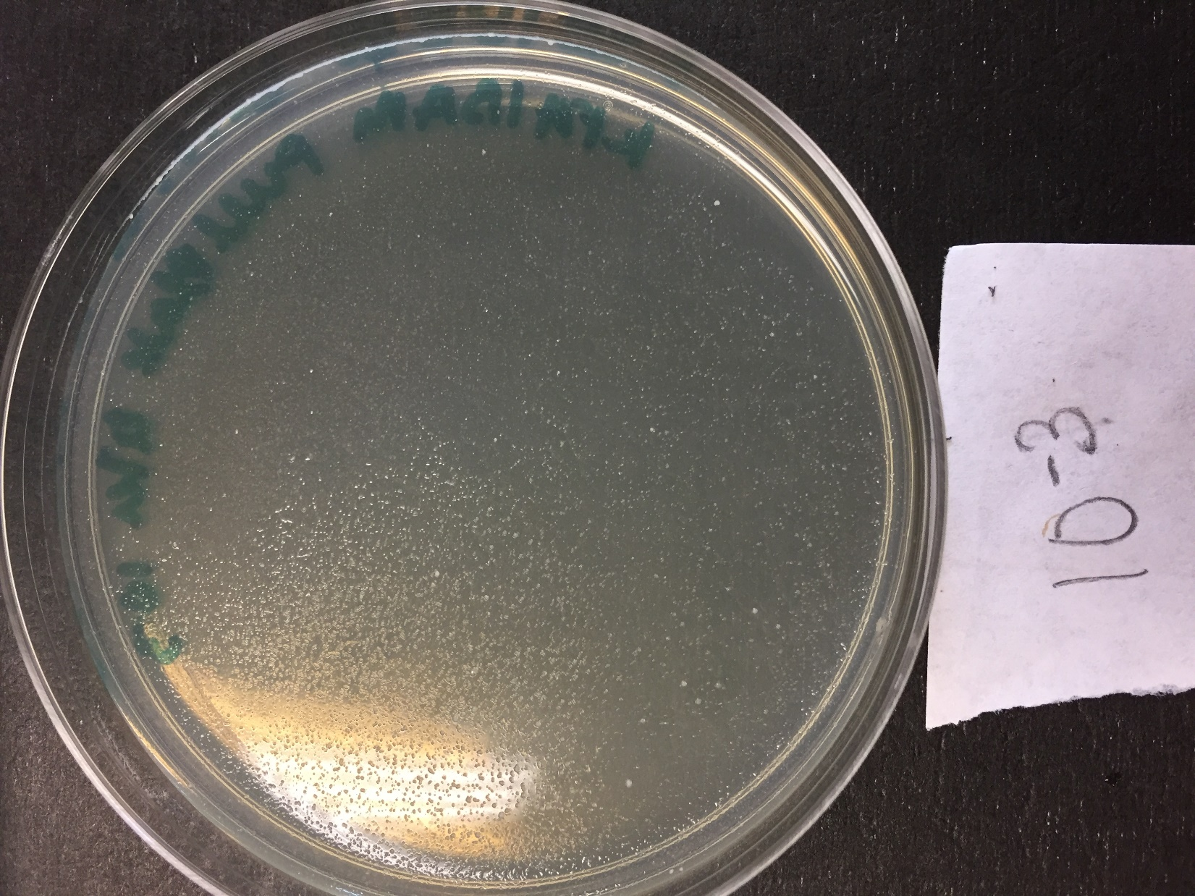

*Figure 79: Full Plate Titer, 10^-3*

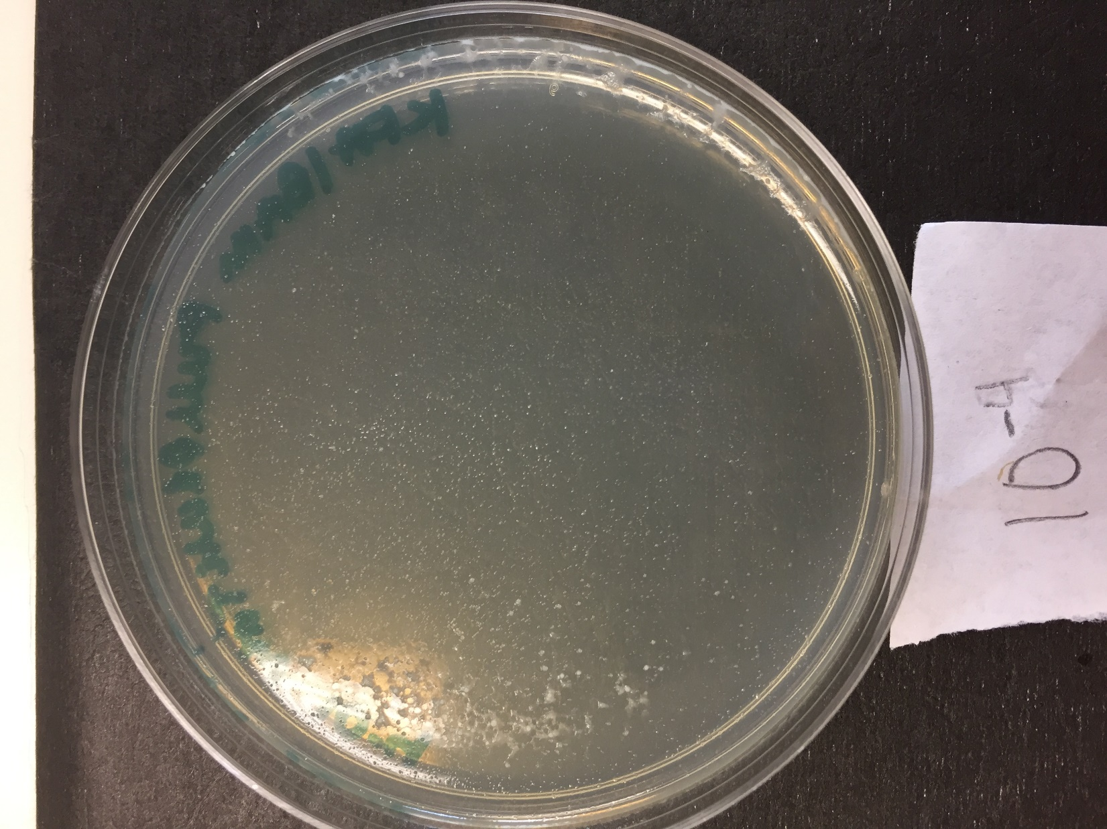

*Figure 80: Full Plate Titer, 10^-4*

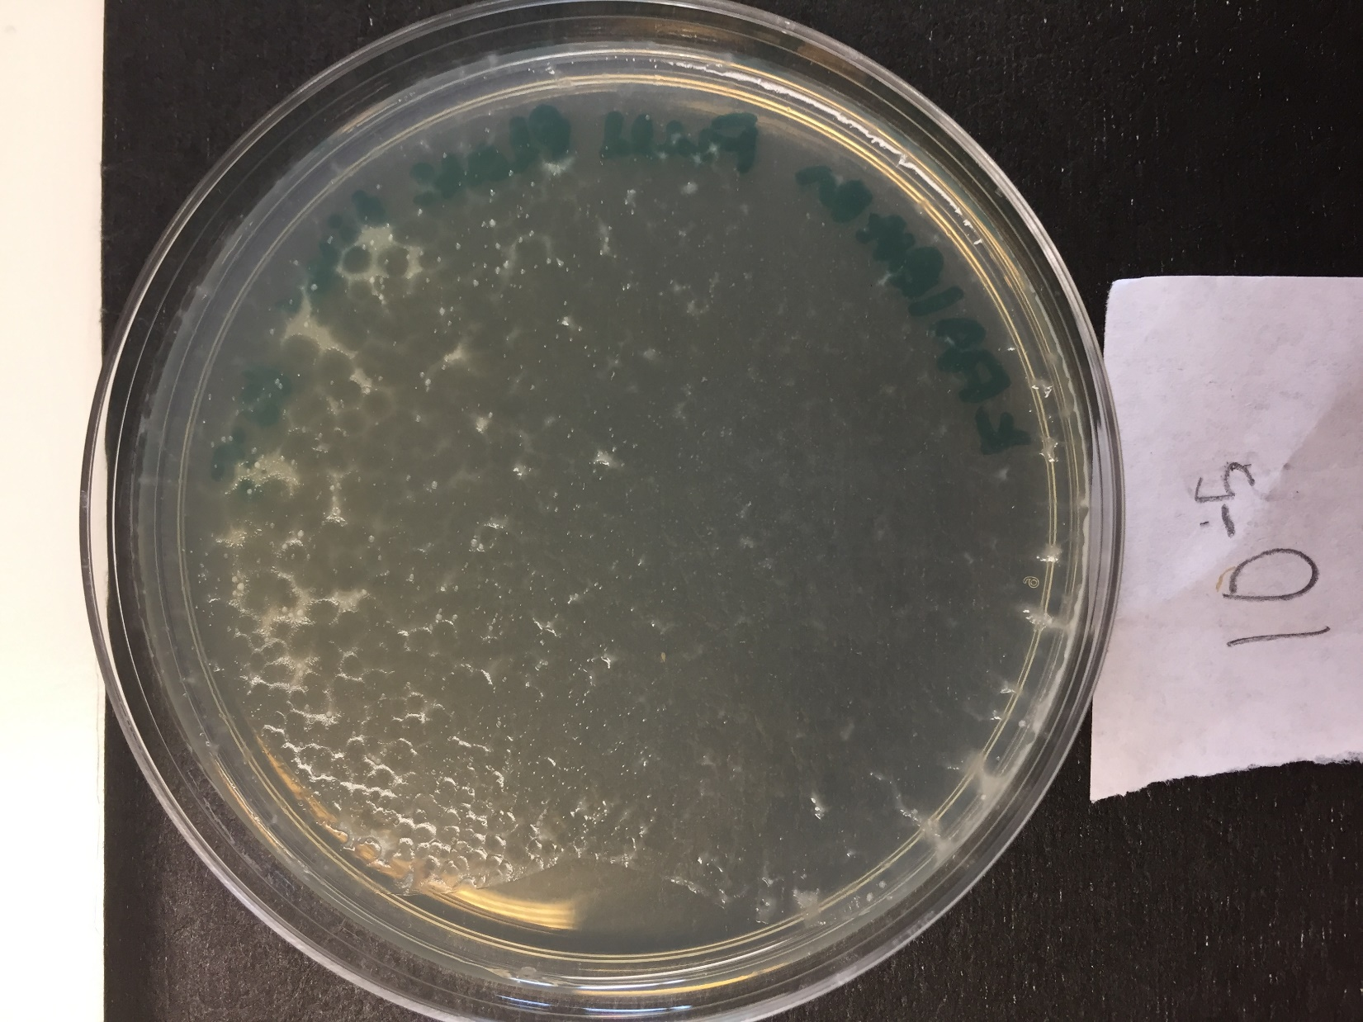

*Figure 81: Full Plate Titer, 10^-5*

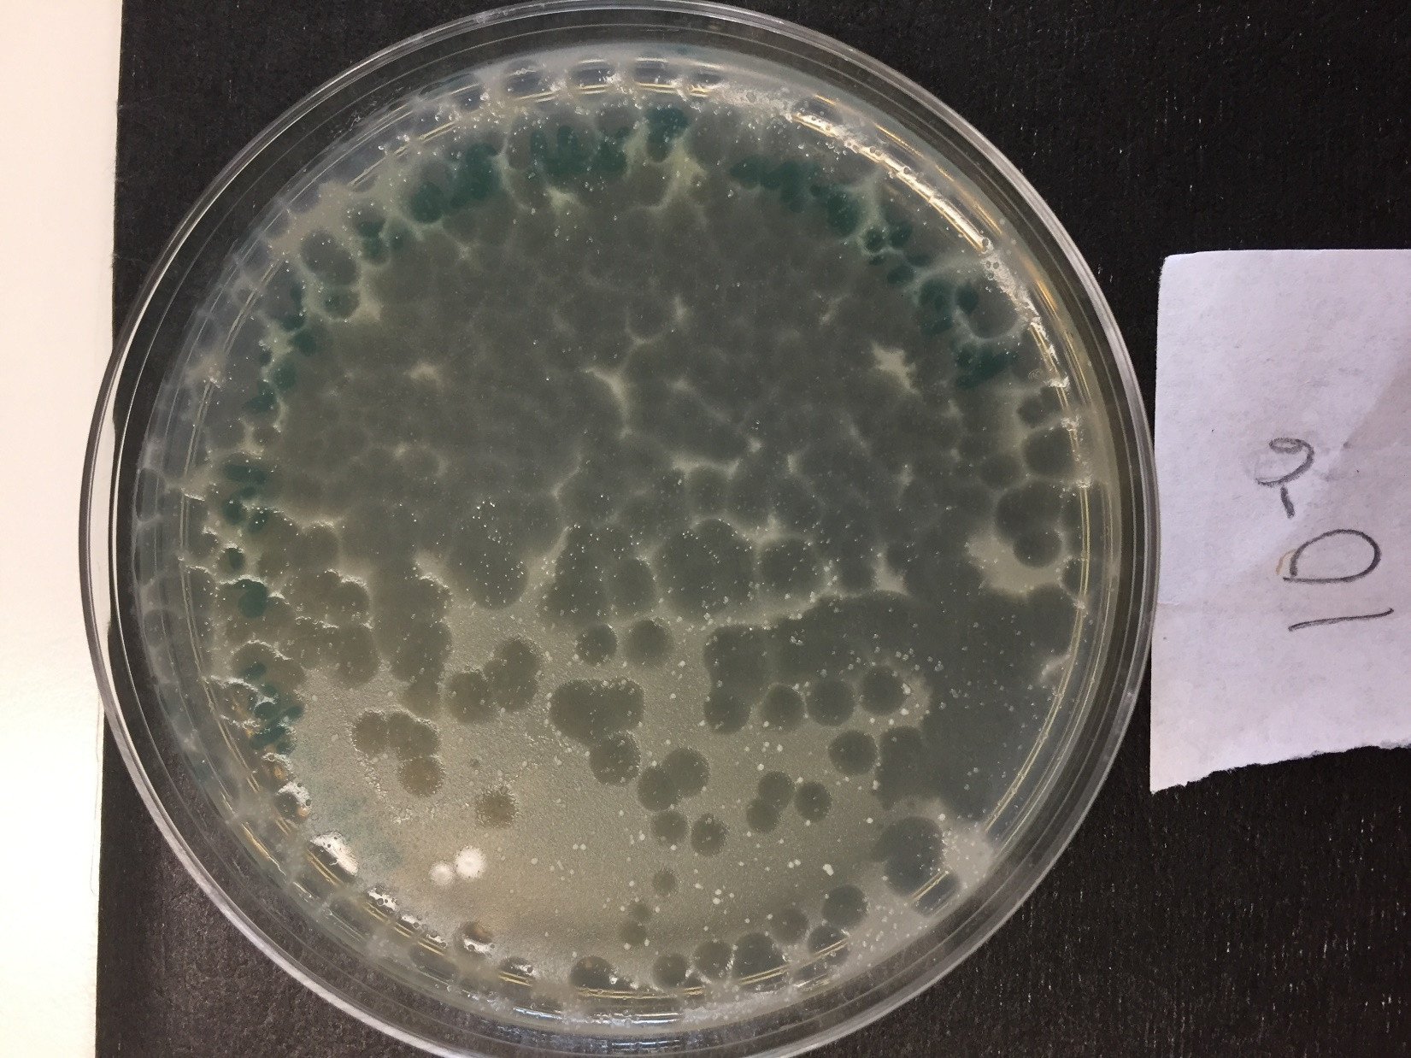

*Figure 82: Full Plate Titer, 10^-6*

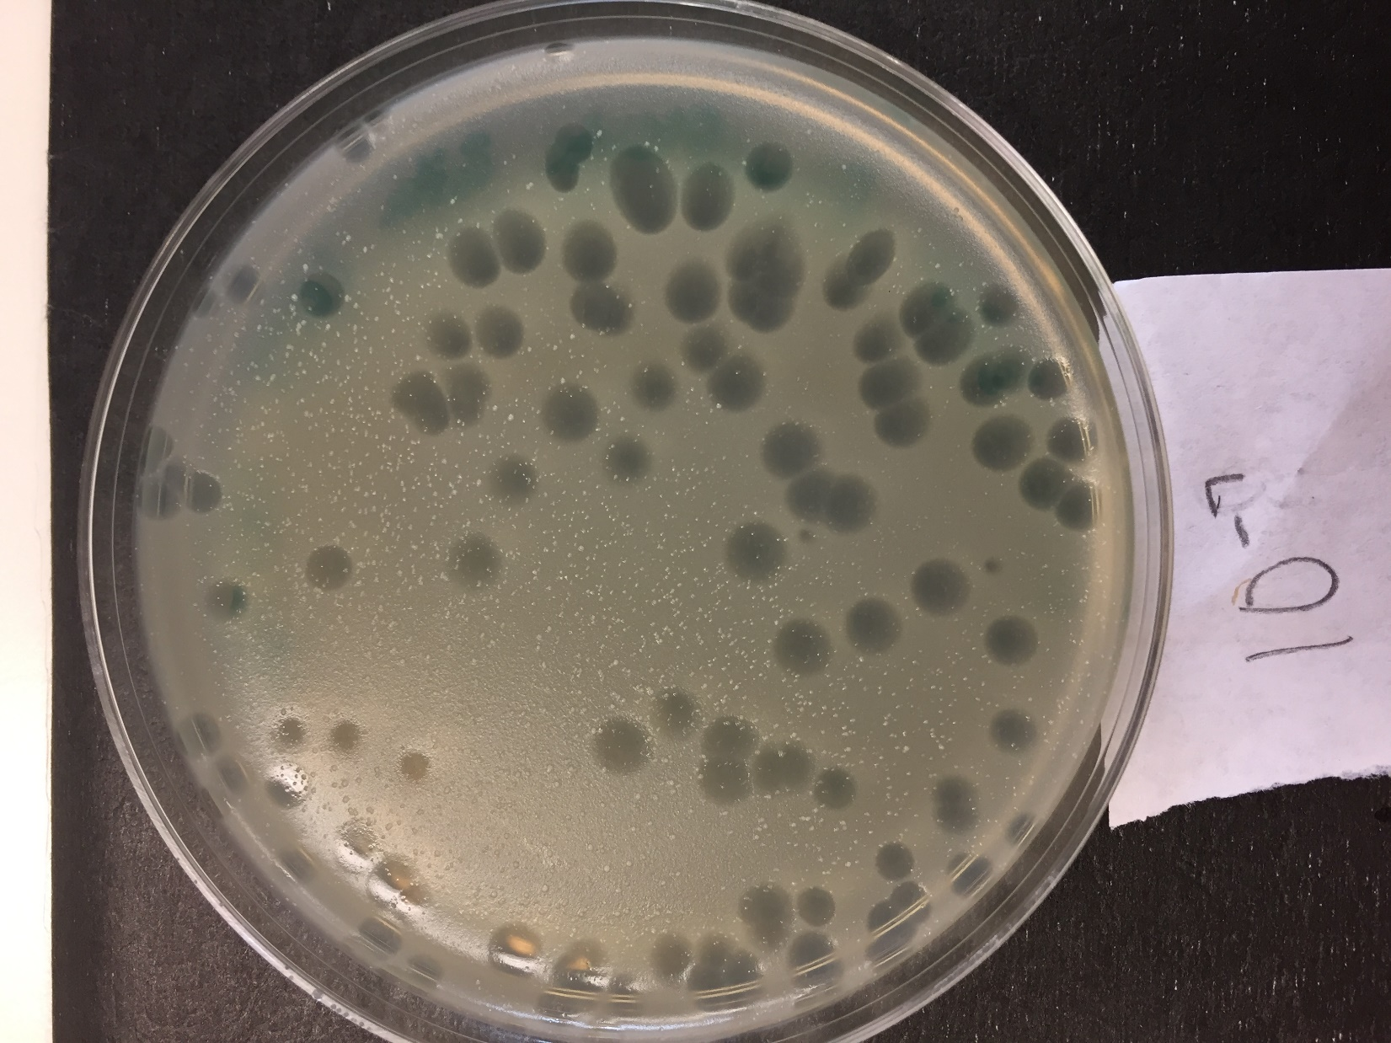

*Figure 83: Full Plate Titer, 10^-7*

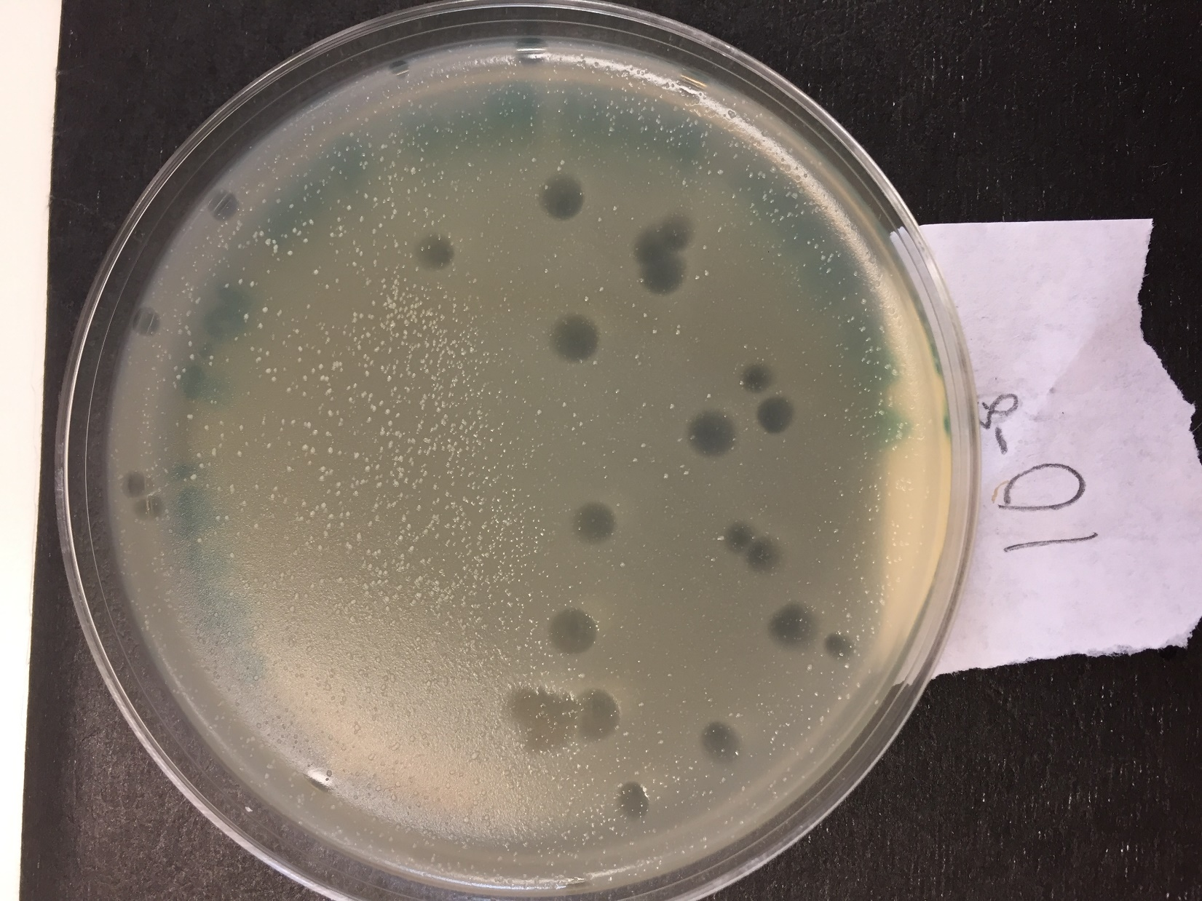

*Figure 84: Full Plate Titer, 10^-8*

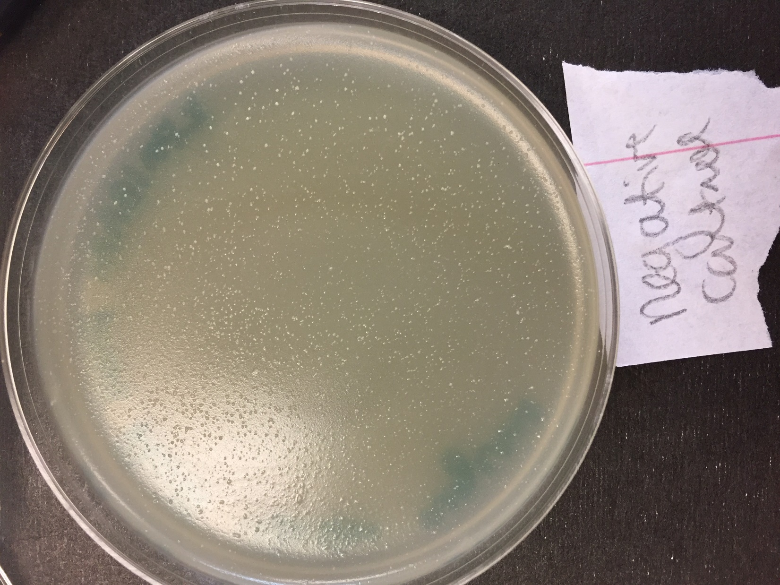

*Figure 85: Full Plate Titer, Negative Control*

**Future Actions**

On Thursday, November 3, 2016, we will perform the DNA extraction on the lysate.

Thursday, November 3, 2016

Thursday, November 3, 2016

11:30 AM

**Objective**

* To isolate genomic DNA from phage

**Procedure**

* I followed the DNA extraction protocol today.
  + I walked into lab, washed my hands and my lab bench.
  + I transferred 1 ml of lysate to a microcentrifuge tube
  + My partner and I cleaned up our workspace and washed our hands
  + We walked to Bindley with Soo
  + We put on gloves and added 5 microL of nuclease to the lysate
  + We inverted the tube 20 times then incubated it at 37C for 10 minutes
  + We took off our gloves and learned how to denature the protein capsid and use the syringe, column, and plunger
  + We put on a fresh pair of gloves
  + Soo gave us a 15-ml conical tube with 2ml of DNA clean up resin.
  + We used a micropipettor to transfer the contents of our microcentrifuge tube to the conical tube.
  + I inverted the tube for two minutes
  + We assembled two column-syringe apparatus
  + We put about 1.5ml of the conical tube's contents into each syringe, then inserted the plunger over a new conical tube. We pushed the liquid through the column, took off the column, took out the plunger, and poured the liquid off into the old 15ml conical tube.
  + We repeated the above process with 2ml isopropanol three times.
  + We transferred the columns to microcentrifuge tubes, labeled the columns with a black marker, and centrifuged them for 5 mins at 10,000 x g. We then changed the microcentrifuge tubes and centrifuged again for 1 more minute.
  + We put our columns in a heating block for one minute, took them out again, then added 50 microL of water to the columns.
  + We centrifuged the columns again for one minute at 10,000 x g.
  + We went upstairs and learned how to work the Nanodrop.
  + Soo showed us how to work the Nanodrop with the water droplet to initialize. I then repeated the technique with the blank water droplet (1.5 mciroL). My partner repeated the technique again with our DNA sample.
  + We printed off the data (See Figure 86).
  + We went back downstairs, washed our hands, cleaned off our workspace, and gave Soo our DNA sample to store for next week.

**Data**

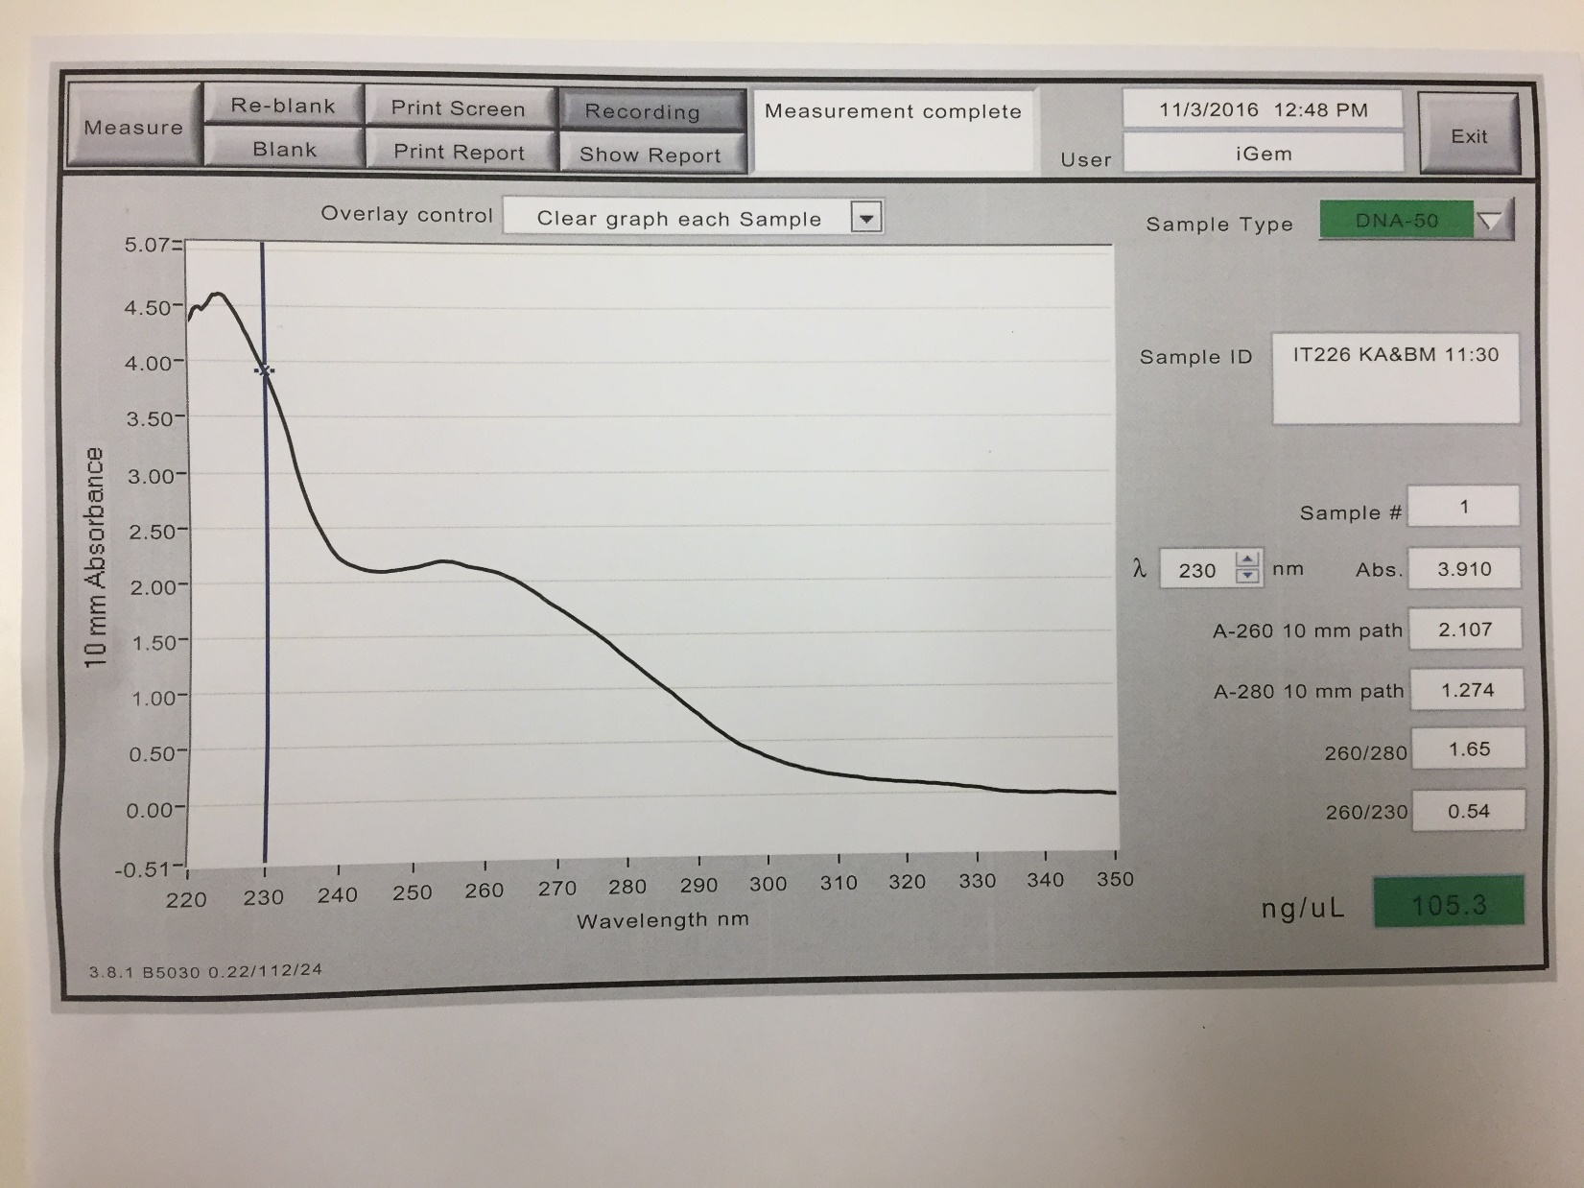

*Figure 86: Nanodrop Data of Extracted DNA*

The concentration of our extracted DNA, as determined by the Nanodrop is 105.3 ng/uL.

* This is sufficient to perform the next step, without needing to re-extract DNA

**Future Actions**

* On Tuesday, November 8, 2016, we will perform the Setting Up Restriction Enzyme Digests protocol

Tuesday, November 8, 2016

Tuesday, November 8, 2016

11:30 AM

**Objective**

* Include phage in the Actinobacteriophage Database to make it available for other scientists
* Prepare a high-titer lysate for long-term storage
* Cut phage genome into multiple fragments based on its DNA sequence

**Procedure**

* I followed the Entering a Phage into the Actinobacteriophage Database, Archiving Your Phage Sample, and Setting Up Restriction Enzyme Digests protocols
  + I walked into lab, washed my hands, and cleaned off my work bench.
  + My partner and I discussed a name for our phage.
    - We decided on BoilerPete.
  + My partner used the SEA-PHAGES app to register our phage into the database.
  + I labeled the tubes to store the phage with the phage name.
    - We used a black marker originally, but that began to rub off of the tube, so we used a red Sharpie to ensure that the name stayed intact on the side of the tubes.
  + We mixed 2.8 mL of lysate with the DMSO given to us in a tube and vortexed it.
  + We took up 1 mL of the mixture in a micropipettor and transferred it into one of the tubes with glass beads; we used enough so that the beads were just covered with the mixture. We did this again for the second tube.
  + We transferred the rest of the mixture to the tube to be stored at Purdue.
  + We threw away the pipette tips and the empty tube into biohazard.
  + We obtained our phage DNA sample
    - Stephen had found it out on the counter instead of in the fridge. As DNA is a stable molecule, it should be okay to continue working with it.
  + My partner vortexed the sample and then incubated it at 65 degrees C for 10 mins.
  + We calculated the volume needed to obtain 0.5 ug of DNA.
    - The volume needed is 4.75 microL.
  + We labeled the microcentrifuge tubes we would need the
  + We re-labeled the DNA microcentrifuge tube for NMR
  + We determined how much water we would need to put in our enzyme tubes
    - 25-7.75=17.25 uL
  + We completed filling our microcentrifuge tubes, centrifuged them, and placed them in a 65 degree C water bath until next time.

**Future Actions**

* On Thursday, November 10, 2016, we will perform the Casting Agarose gels and Gel Electrophoresis of Restriction Enzyme Digests protocols.

Thursday, November 10, 2016

Thursday, November 10, 2016

11:30 AM

**Objective**

* Prepare an agarose gel for electrophoresis
* Separate DNA fragments via agarose gel electrophoresis

**Procedure**

* I followed the Casting Agarose Gels and Gel Electrophoresis of Restriction Enzyme Digests protocols today.
  + I walked into lab and washed my hands while my partner cleaned off my work bench.
  + We received an Erlenmeyer flask from Yi to share with another group.
  + My partner measured 0.8021 grams of powdered agarose
  + Yi added 100 ml of TB buffer to the Erlenmeyer flask
  + He added the measured powder, swirled the flask, and microwaved it for 1 minute
  + He swirled the mixture again and microwaved it again for 20 seconds
  + He swirled it again and microwaved it for another 10 seconds
  + We waited 15 minutes for the gel to cool
  + Yi set up the work space for us and added the dye to the Erlenmeyer flask
  + He poured out the mixture into a gel mold
  + We obtained the restriction enzyme-DNA mixtures that we prepared on Tuesday
  + My partner held the loading dye so as to melt it, as it was still frozen from being stored on ice
  + We added 5 microL of loading dye to each of our enzyme-DNA mixtures
  + We incubated the mixtures for 5 minutes at 65 degrees C in a water bath
  + The samples were put on ice for a minute then microcentrifuged for 2 seconds
  + We loaded our samples into the left side of the gel in the order stated by the protocol
  + We ran the gel at 100 volts for 60 minutes
  + We cleaned up our work area and washed our hands.

**Future Actions**

* On Tuesday, November 15, 2016, we will analyze the results of the gel.

Tuesday, November 15, 2016

Tuesday, November 15, 2016

11:30 AM

**Objective**

* To examine and interpret the results of the restriction enzyme digest.

**Procedure**

* I followed the Analyzing Restriction Enzyme Gels protocol today.
  + I walked into lab, washed my hands, and cleaned off my work bench.
    - My normal bench was being used for gels, so I went to a bench of a team that was doing EM today.
  + We found the picture of our gel on blackboard, and were happy with the results.
  + We measured the distances of the ladder bands and the streaks of DNA from the bottom of the well.
    - There were no bands of DNA from our phage, possibly due to the expired nature of the enzymes.
  + We created a plot of the ladder's data, then used the normalized equation from the data (see Equation 1) to determine the phage DNA base pairs.
  + We cleaned off our workspace and washed our hands.

**Data**

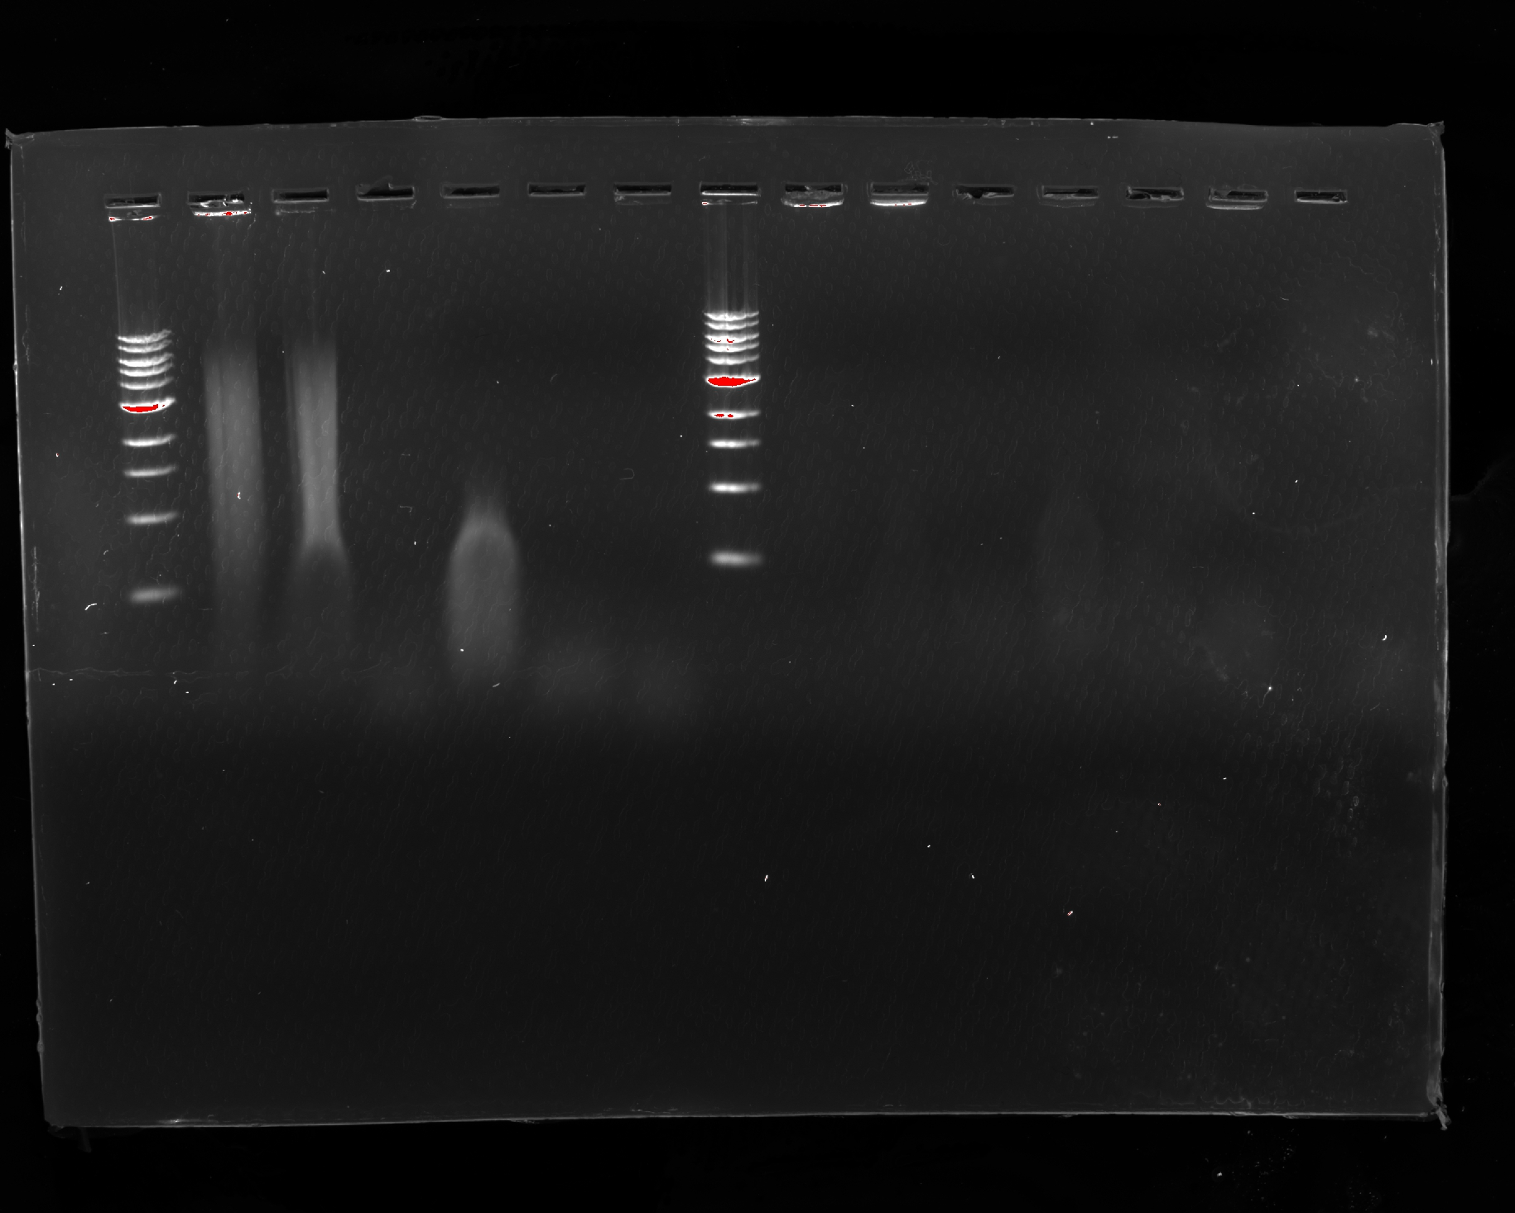

*Figure 88: Gel Electrophoresis Results -- Left Side*

*Table 17: Distance of Ladder DNA Fragments*

|  |  |
| --- | --- |
| Distance Traveled (mm) | DNA Ladder Fragment Size (bp) |
| 42 | 10000 |
| 52.5 | 6000 |
| 60 | 5000 |
| 65 | 3000 |
| 77 | 2000 |
| 88 | 1500 |
| 104 | 1000 |
| 131 | 500 |

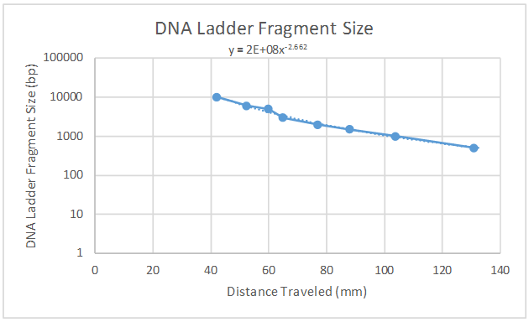

*Figure 89: Semi-logarithmic graph of DNA Ladder Fragment Size vs. Distance Traveled*

*Equation 1: Normalized Equation for Fragment Size vs. Distance Traveled*

Y = 2 * 10^8 * x^-2.662

*Table 18: Distance of DNA Fragments for Phage DNA in mm*

|  |  |  |  |  |  |  |
| --- | --- | --- | --- | --- | --- | --- |
| Enzyme | Uncut DNA | BamHI | ClaI | EcoRI | HaeIII | HindIII |
| Min Distance of Streak (mm) | 50 | 50 | 160 | 110 | 160 | 170 |
| Max Distance of Streak (mm) | 130 | 120 | 180 | 160 | 180 | 180 |

*Table 19: Size of DNA Fragments for Phage DNA in Base Pairs*

|  |  |  |  |  |  |  |
| --- | --- | --- | --- | --- | --- | --- |
| Enzyme | Uncut DNA | BamHI | ClaI | EcoRI | HaeIII | HindIII |
| Max size (base pairs) | 6003 | 6003 | 271 | 736 | 271 | 231 |
| Min size (base pairs) | 472 | 584 | 198 | 271 | 198 | 198 |

**Future Actions**

* On Thursday, November 17, 2017, from 1pm - 2pm, we will be performing the EM analysis on our phage DNA.

Thursday, November 17, 2016

Thursday, November 17, 2016

11:30 AM

**Objective**

* To view a phage sample with an electron microscope

**Procedure**

* I arrived at Whistler Hall ten minutes early and found the room
* Soo instructed me to find my sample, but it could not be found, so my partner and I walked to the DLRC to make a new sample
* We entered lab, washed our hands, and cleaned off our lab table.
* We got the Bunsen burner, the microcentrifuge tube needed to hold our sample, the pipette and tip, and the lysate.
* We pipetted 100 microL of lysate into the microcentrifuge tube.
* We cleared our work bench, returned the lysate to the fridge, cleaned the work bench, and washed our hands.
* We walked back to Whistler, and Bob, the electron microscope expert, prepared our sample and put it into the microscope.
* We found a bunch of phages in the sample and Bob took pictures of them for us.
* The head of the bacteriophage has a diameter of 86 nm. The tail of the bacteriophage has a length of 283 nm.

**Data**

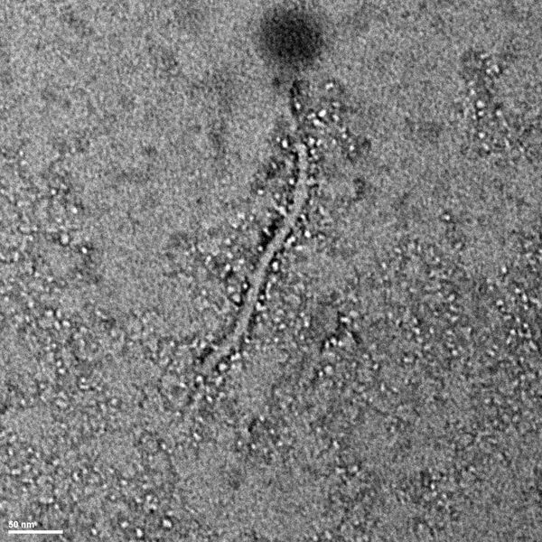

*Figure 90: Electron Microscopy Image 1*

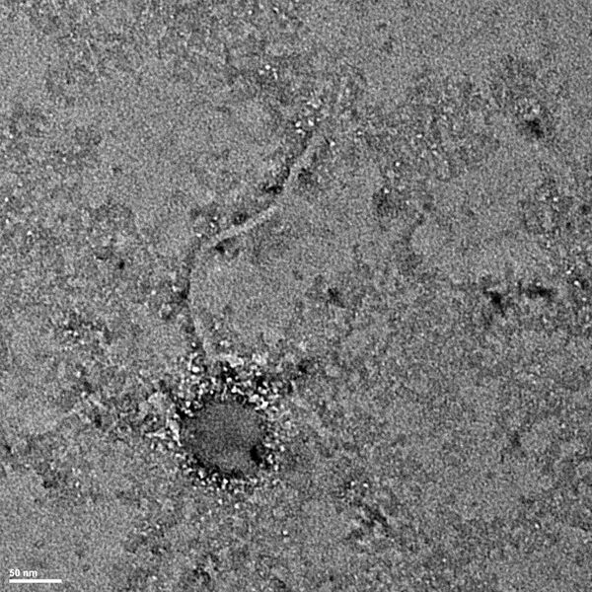

*Figure 91: Electron Microscopy Image 2*



*Figure 92: Electron Microscopy Image 3*

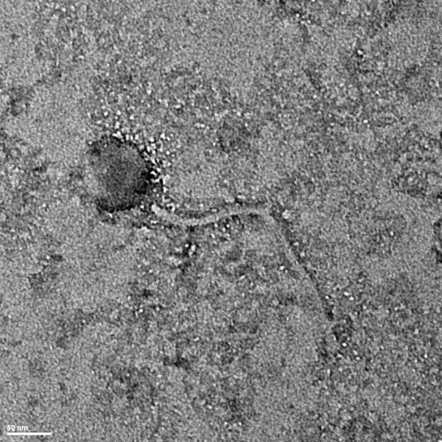

*Figure 93: Electron Microscopy Image 4*

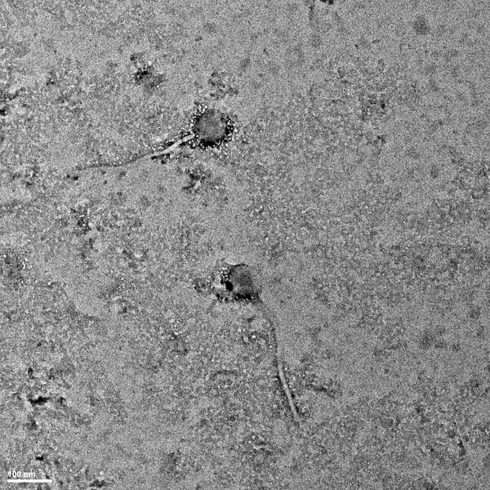

*Figure 94: Electron Microscopy Image 5*

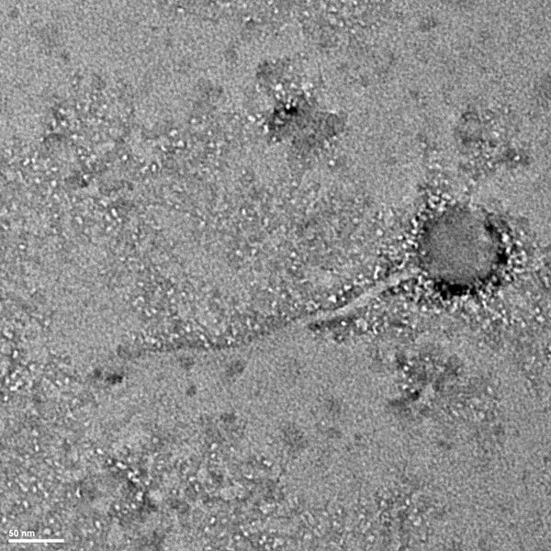

*Figure 95: Electron Microscopy Image 6*

**Future Actions**

* When the pictures come out, my partner and I will measure the tail of our phage.

Tuesday, November 29, 2016

Tuesday, November 29, 2016

11:30 AM

**Objective**

* To work on research paper, complete course evaluations, and update the phage's database page

**Procedure**

* I walked into lab and washed my hands.
* At my work bench, my partner and I worked on the course evaluation and survey sent to us.
  + Soo's email said we should have gotten four separate emails from Dr. Clase with four different surveys, and my partner and I only received one, so we just worked on that one and the Purdue course evaluation. We took screen shots of our surveys and put them in a draft email to Soo. We will put the rest of the screen shots in once the rest of the emails are received and the rest of the surveys are sent out.
* I created a Google doc and slide file for our research paper and presentation.
* My partner updated the phage's database, as the page was created under her account.

**Data**

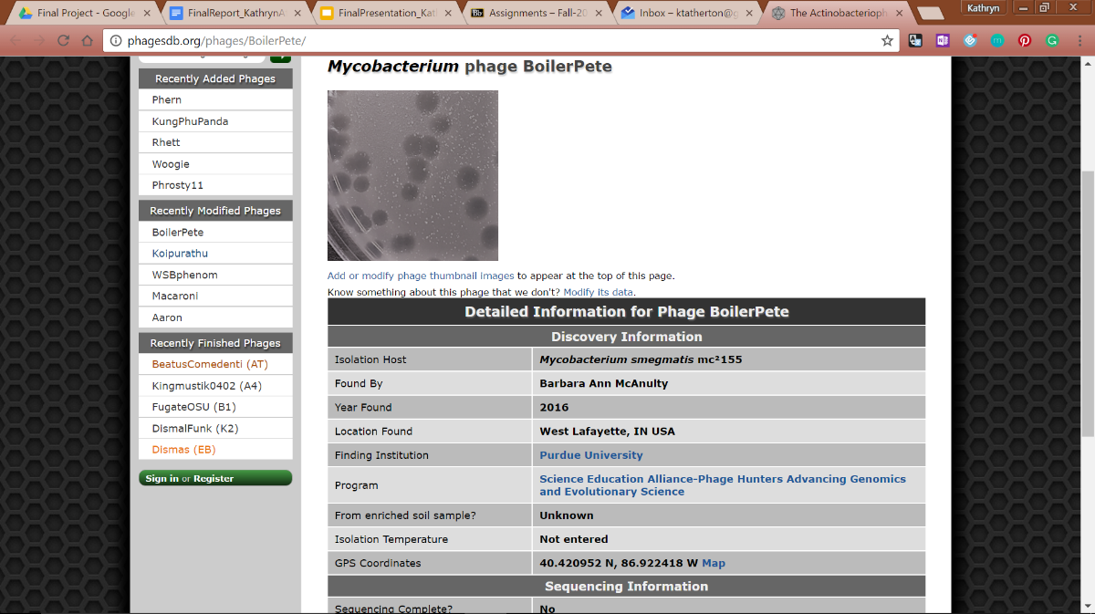

*Figure 96: Updated Phage Database Page for BoilerPete*

**Future Actions**

* On Thursday, December 1, 2016, my partner and I will continue to work on the final project.

Thursday, December 1, 2016

Thursday, December 1, 2016

11:30 AM

**Objective**

* To write the report and create the presentation.

**Procedure**

* My partner and I went to lab to work on the poster and report so that if we had any questions they could be answered.

**Future Actions**

* On Tuesday, December 6, 2016, my partner and I will present our semester's work to the class.

Tuesday, December 6, 2016

Tuesday, December 6, 2016

11:30 AM

**Objective**

* To present the team's findings to the class
* To hear about other teams' research experiences

**Procedure**

* My partner and I presented our final presentation in class today.
* We also heard half of the other groups present their work from the semester.

**Future Actions**

* On Thursday, December 8, 2016, my partner and I will hear the rest of the groups' findings.

Thursday, December 8, 2016

Thursday, December 8, 2016

11:30 AM

**Objective**

* To hear about other teams' research experiences.

**Procedure**

* My partner and I heard the rest of the class's findings from the semester.

**Future Actions**

* By Tuesday, December 13, my partner and I will turn in our final reflections and final research papers.